**Setting up and using the Face to Face Group Enrolment Plugin**

Installation.

There is a technical guide detailing how to apply the customisations made to the Face to Face activity module to the latest version and how to install the Face-to-face Group Enrolment plugin. Both of these are required for the group enrolment feature to work. However, the customisations to the Face to Face module can be used as a stand-alone feature which allows for signing users up to sessions (or taking them out of them) based on their group membership.

Face to Face Activity Module custom features.

Setting up Groups in your course

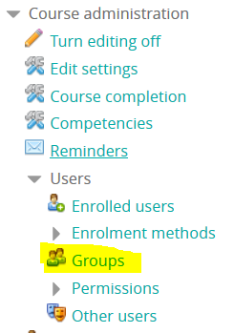This feature depends on setting up groups. Groups are set up in the normal way while using this feature.

Creating a Face to Face module

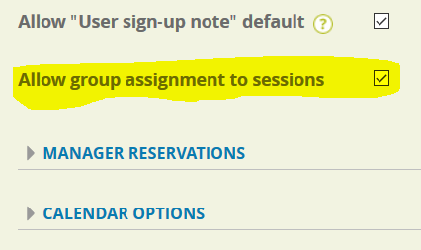*Face to face modules can be created in the standard way, by turning on editing*, clicking the *Add an activity or resource* link and selecting the *Face to Face* option. When creating the module, ensure that the *Allow group assignment to sessions* option is checked, as displayed.

The feature is designed to support the existing settings such as *Approval Required* (so that managers will receive an approval request when users are prospectively added to a session) and *Allow multiple session signups per user*.

Creating a new Face to Face session

Once the Face to Face activity is created, you create a new session by viewing the activity and clicking the *Add a new session* link.

Most of the custom features are under the new *Groups* tab. If you did not enable the *Allow group assignment to sessions* option while creating the Face to Face module, above, you will see the following message

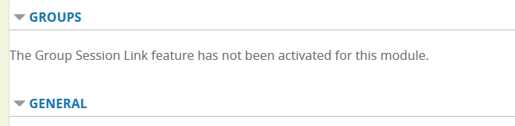

After activating this option, you will see the following:

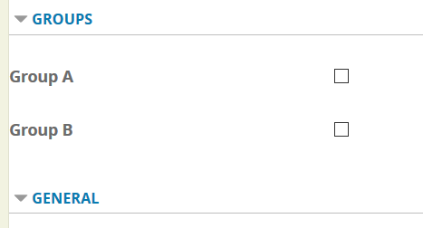

Select the group that you want to link to this session.

Click *Save changes* at the bottom of the page.

In the activity page, you should now see an entry such as the following in the *Upcoming* Sessions table:

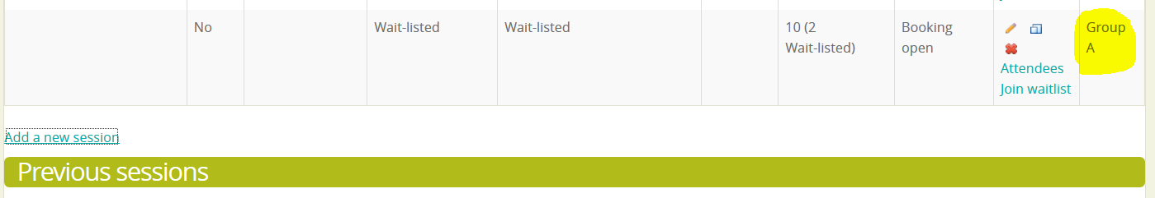

Note that the group you assigned to the session is displayed in the table.

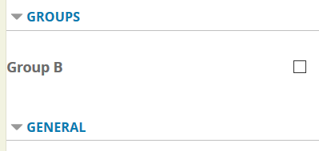

If you add another session then you will see that the group you selected above is now missing from the list. That is because a group may only be assigned to a single session per Face to Face activity. As such, you will need to have at least as many groups as you have sessions in an activity if you want every session to use groups.

Using the Face-to-face Group Enrolment plugin

That's it! With the above step of assigning a group to a session, you have signed up any users who belonged to that group to the session. If you go back to the group management page and add further users to the group, then they will also be signed up to the sessions that the group is assigned to.

Q: What happens if I remove a user from a group.

A: If a user is removed from a group then they are removed from sessions that the group is assigned to **unless** they also belong to another group that is assigned to the same session.

Q: What checks are performed during the automatic sign-up to ensure that the user is able to sign up to a session?

A:

* If the user is already signed up to another session and cannot sign up to multiple, then they cannot sign up.
* If the last sign up date is set and it is in the past, the user cannot sign up.
* If overbooking is not allowed and there are no seats left only Site Admin users can sign users up. This matches the default set-up of Face to Face. This means that (deep breath!) if a standard (non-site) admin adds users to groups or groups to sessions then the affected users will not be signed up to the session if there is no capacity and overbooking is not allowed.

Setting up the Face-to-face Group Enrolment plugin

The Face-to-face Group Enrolment plugin has been designed to be separate from the standard totara_facetoface enrolment plugin. Both can be installed and used alongside each other, if desired.

Some extra set-up of the Face to Face activity module

You may want to set up the custom session fields and sign-up notes before setting up the enrolment plug-in as these may be used within the sign-up process. Select *Custom Fields* as follows:

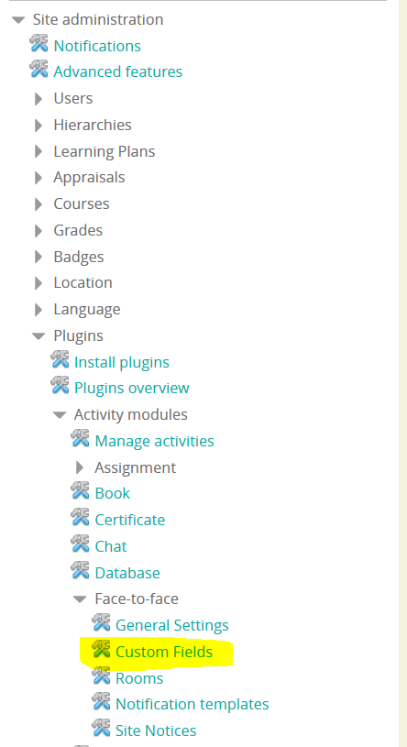

This allows you to create both custom session fields and sign-up notes.

You may also want to set up the *Last Sign-up Date* in the *Session Edit* page. This is another custom edition:

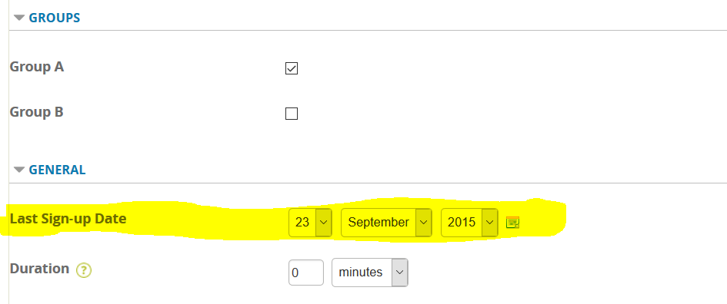

This will be used, along with the Session start time, to determine the deadline for signing up to a Group via the enrolment plug-in.

Setting up the enrolment plugin

First, ensure that the Face-to-face Group Enrolment plugin is enabled in the Site Admin menu:

*It will appear as Xtractor Face-to-face GSL direct enrolment* and the eye should be **open** to indicate that it is

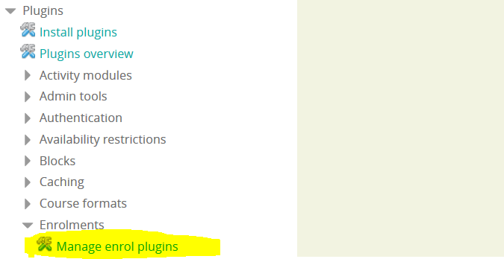enabled.

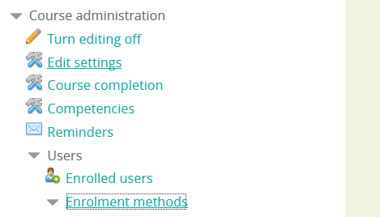Next, add this as a new enrolment method to the course you are working with.

Once you have added the method, click edit:

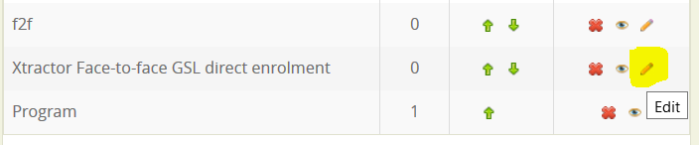

Many of the options here are identical to the options provided in the standard Face to Face enrolment plug-in. The difference is the absence of the **Automatically sign users up to face to face sessions Help with Automatically sign users up to face to face sessions** option (since users are always automatically signed up in this plug-in) and the addition of the **Sign-up fields for this enrolment** and **Groups** tabs.

**Sign-up fields for this enrolment tab**

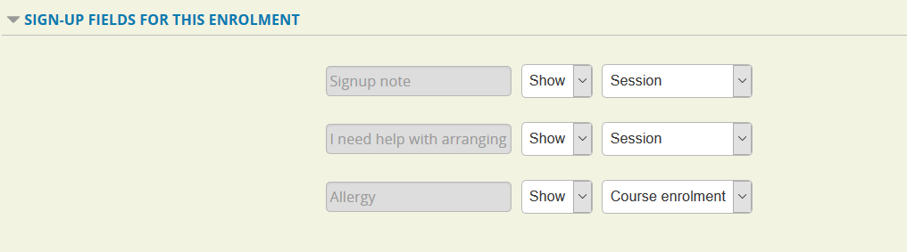

This tab makes use of the custom sign-up fields that you may have set up above. You can show or hide them from the sign-up process and you can change whether they appear as fields attached to each session or as a value to be entered once only (*course enrolment*). In the latter option, the value provided is used for the sign-ups to each of the sessions.

**Groups tab**

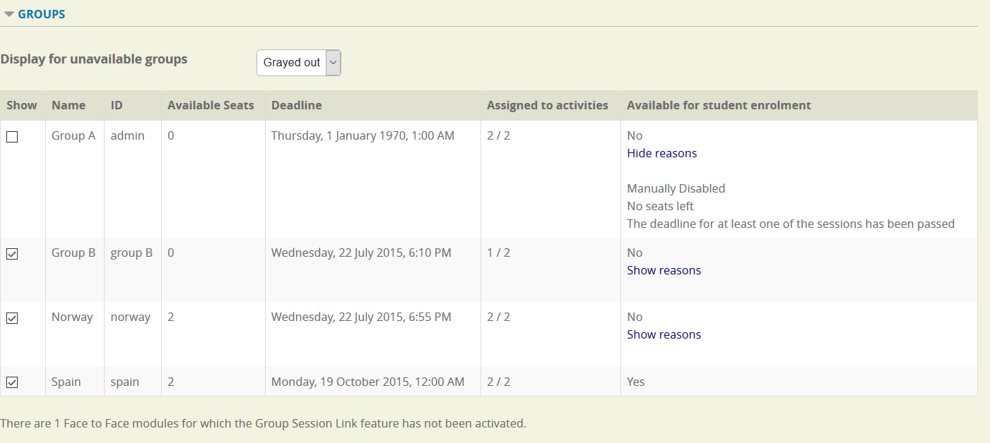The first option allows you to select how groups that are not available for enrolment are displayed, whether they are hidden or displayed with an explanation of why they are not available. In the latter case, the radio button to select them will be grayed out.

The Groups table allows you to manually disable a group for the plug-in (Under the **Show** column).

The **Assigned to activities** column displays how many of the Face to Face activities in the course contain a session that the group is assigned to. Note: the total for this (2 in the above screen shot) does not include Face to Face activities for which the *Allow group assignment to sessions* option is disabled.

The **Available for student enrolment** column will display whether the group can be selected by a user in the sign-up process and if not, why not.

The text below the table displays the number of Face-to-face activities for which the *Allow group assignment to sessions* option is disabled.

Q: What are the reasons for a group not being available for a user in the sign-up process?

A:

* The group has been manually disabled (by the checkbox in the **show** column).
* The group has not been assigned to a session in one of the Face-to-face activities for which the *Allow group assignment to sessions* option is enabled.
* There is no capacity left in the group. Note: this plug-in does not support wait-listing in Face-to-face so the session must have free capacity even if it allows for wait-listing.
* The deadline has been passed.

Q: How is the deadline for sign-up to a group calculated?

A: The deadline for a group is the earliest deadline of all its sessions.

A deadline for a session is either:

* The earliest start time for the dates of the dates of the session, or

* The 'last signup date'.

Whichever of the two is sooner.

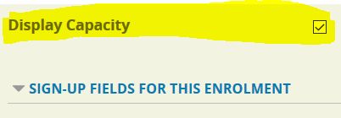There is another option, *Display capacity*

This determines whether to display the number of spaces left to the student when signing up (in the first stage of sign up).Using the enrolment method as a student

When you try to access the course as a student, you will see a list of the groups that you could see as an admin (unless the display of unavailable groups is set to hidden). When you select a group, a gray bar will appear beside the details of the selected group.

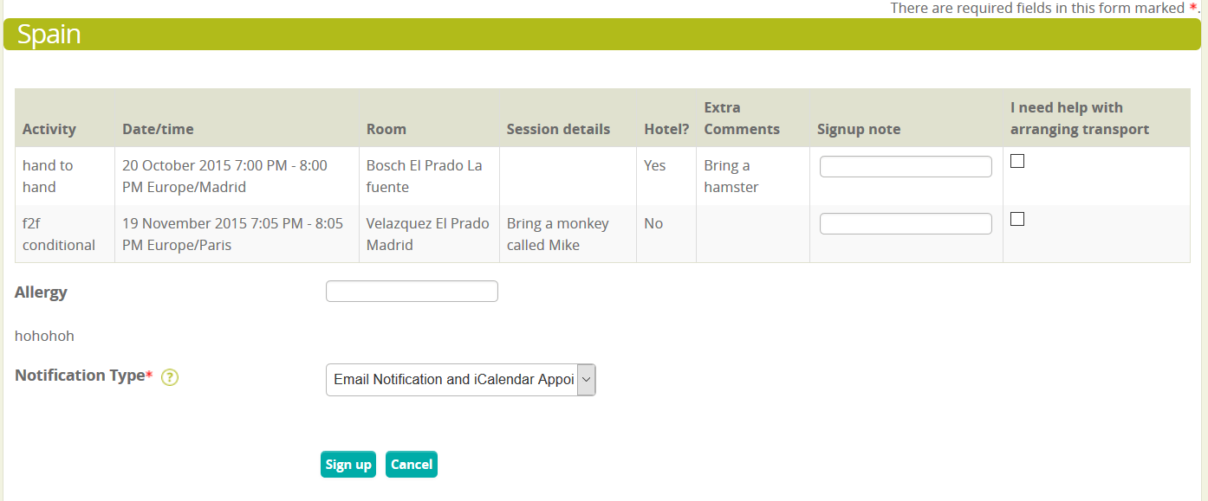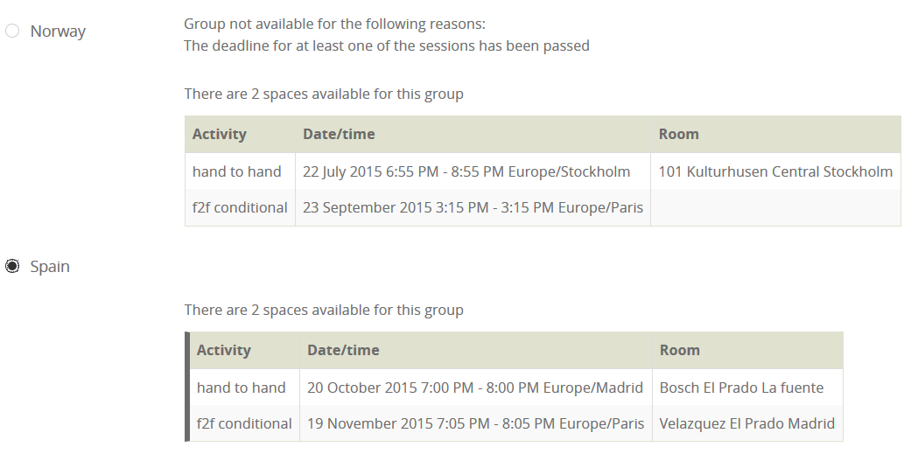After submitting the first stage, you will see the following second stage screen:**As described above, the Allergy** sign-up field was set as a course-wide field, which is why it is displayed below, rather than in the table.

Once filling out required fields and clicking *Sign up*, you will be enrolled onto the course and signed up to the appropriate sessions.

