Custom Profile fields have to be set to “Visible to everyone”
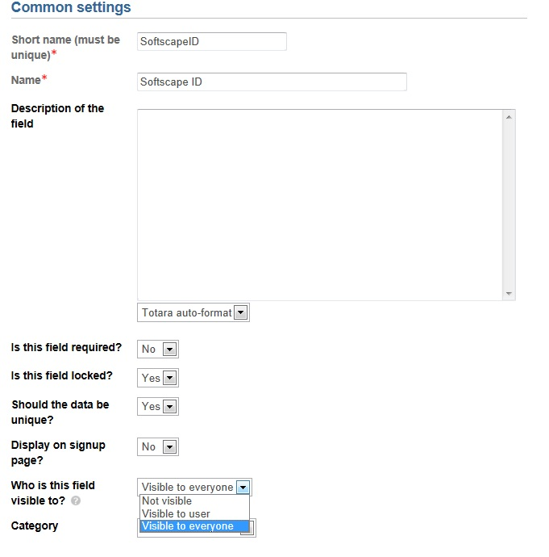

For the “Local HR manager” role to be able to see the columns in their Elearning Status Report:

This is sensitive information which shouldn’t be visible to other learners. Is there a capability to allow Local HR Managers to see these fields (specifically in reports) when they are set to “Visible to user”, or a capability to prevent learners from seeing the fields when they are “Visible to everyone”?

