I made an audience with programs and courses
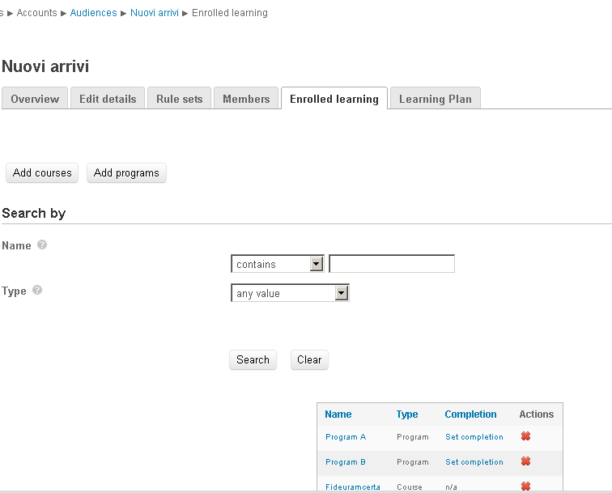

In same audience I set membership based on position (nuovi arrivi)

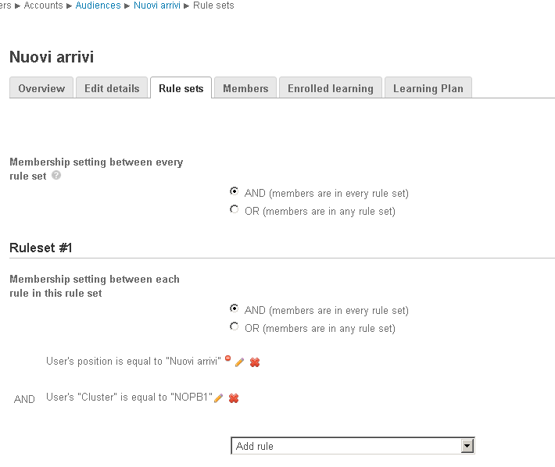

Then I upload users by sync with the correct posidnumber to match Rule Sets.

After this I launch cron php to run audience .
After these, users with correct numberidposition are enrolled on courses but not are enrolled to programs as set on audience.

To fix this issue I go to specific program (Program A in this case) and I click on “Save changes” button in Assignements tab.

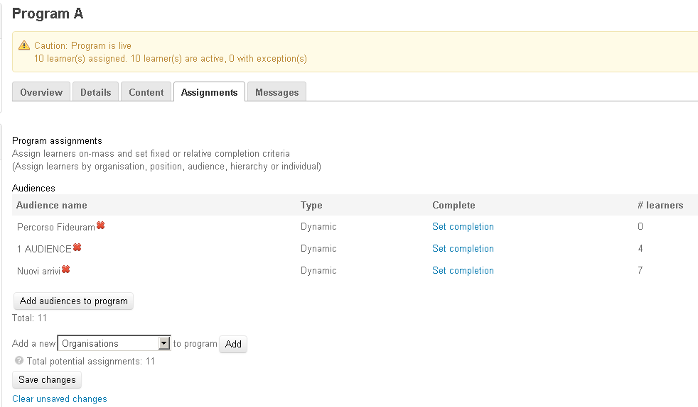

After this, all users are enrolled on Program A.
I think users should be enrolled after cron running.

