Working with Face-to-face Activities
A Guide to the Delivery of Instructor-led Training in Totara LMS

Last updated | 20 June 2013
Document version | 0.5

Contents
Introduction 3
Benefits of Using Face-to-face Activities 3
How Face-to-face Activities Work 4
Site Administrator Workflow 5
Set up Permissions 5
Manage Site-wide Configuration Settings 8
Enable Face-to-face Activities 8
Manage Face-to-face Activity Settings 9
Configure Site-wide Face-to-face Session Reports 20
Course Creator Workflow 20
Create a Face-to-face Activity 20
Manage Activity Notifications 24
Session Manager Workflow 29
Create a New Session 29
Clone an Existing Session 34
Book Attendees for a Session 34
Trainer Workflow 42
Bulk Message Users 42
Take Attendance for a Session 44
Learner Workflow 46
View Sessions 46
Sign-up for a Session 53
Sign-up for a Session without a Known Date and Time 56
View Current and Past Session Bookings 58
Sign-up for a Session Waitlist 59
Cancel from a Session 59
Manager Workflows 63
Session request approval 63
Viewing team bookings 64
Frequently Asked Questions 66

Introduction
Employee training can be delivered in three forms: self-paced review of written resources and quizzes that may be delivered through a web-based learning management system, on-the-job training that occurs on an ad-hoc basis and instructor-led training that requires learners to appear at a particular date/time and location for hands-on workshops and proctored examination. TotaraLMS allows training teams to manage these disparate methods of training through one system, reflecting the real world interconnection of the different forms of training that can occur in an organization.
The Face-to-face activity allows trainers to manage instructor-led training sessions that otherwise would not be reflected in an eLearning system. Scheduling, notifications and attendance tracking can all be managed within TotaraLMS, the same system that holds both eLearning courses and on-the-job training data. TotaraLMS is then able to provide a more complete picture of the training that the learner is getting, regardless of the form that training takes.
This document’s purpose is to:
Provide the information needed to fully understand the Face-to-face activity
Guide administrators through the steps required to configure, manage and track information from the Face-to-face activity successfully

Benefits of Using Face-to-face Activities
The Face-to-face activity handles scheduling, notifications and tracking of instructor-led training opportunities. Use of this activity can also impact curriculum workflow as well as reporting.
Course/Program Completion
Marking a learner’s attendance of a session adds a grade to the course gradebook for that learner. A grade is awarded based on whether the learner attended the session (100%), partially attended the session (50%) or did not attend (0%). The grade that the learner receives can unlock access restrictions of additional course activities, making resources or activities available based on the learner’s attendance. This can in turn be used toward overall course or program completion. For example, attending a face-to-face session on CPR can be a requirement that must be fulfilled before the learner has permission to access the course exam.

Reporting
Face-to-face session schedules and attendance information can be accessed on a site-wide level by Regional and Staff Managers to track staff attendance at training sessions. The Report Builder allows site administrators to create custom reports and provide access to those reports to other users based on their role in the system. Reports can be filtered on data such as the learners’ organization and position as well as individual session names and date ranges. Report data can be viewed onscreen and exported to a file manually or automatically at a scheduled interval.

How Face-to-face Activities Work
Face-to-face functionality is distributed across multiple roles in the system to replicate a real world training environment. Let’s use an example. ACME Company requires that all learners attend a CPR Certification course upon hire. Attending the onsite instructor-led training is required to complete the employee Orientation course. The training session is offered once a month and the learner is responsible for signing up for and attending the session. The session trainer marks attendance for learners, which staff managers and regional managers will be able to view via reports.
TotaraLMS contains user roles that are granted permissions to perform parts of the process of creating, booking, tracking and reporting on Face-to-face activities.
- Site Administrator configures site-wide Face-to-face activity settings, creates templates for notification messages and designs reports reflecting attendance information as well as granting report view access to other roles.
- Editing Trainer or Course creator creates a new Face-to-face activity in a course page and customizes the notifications associated with it.
- Trainer accesses the activity and creates individual sessions including the date, time, location and trainer for each session. The Trainer may then book learners for the session.
- Learner (staff member) requests a seat by signing up for a session. Learner receives email/dashboard notification of their request.
- The learner’s Manager also receives email/dashboard notification of the sign-up request and may have permission to approve or deny that request.
- Learner attends the session.
- Trainer takes attendance for the session.
- Staff or Regional Manager views reports displaying session attendance data aggregated across all courses and Face-to-face activities.
Notifications setup as a part of the activity will be sent automatically by the system. Notifications can include both emails and alerts on the My Learning dashboard that will be sent to the learner to confirm their booking, remind them of an upcoming session or let them know that a session has been cancelled. The learner’s manager can also receive copies of these messages and may receive a request to authorize a learner’s attendance.

Site Administrator Workflow

Set up Permissions
User roles such as Learner, Trainer and Manager can be granted permissions to access capabilities in TotaraLMS. To view or update permissions for user roles, go to the Settings block and under Site Administration select Users > Permissions > Define roles.
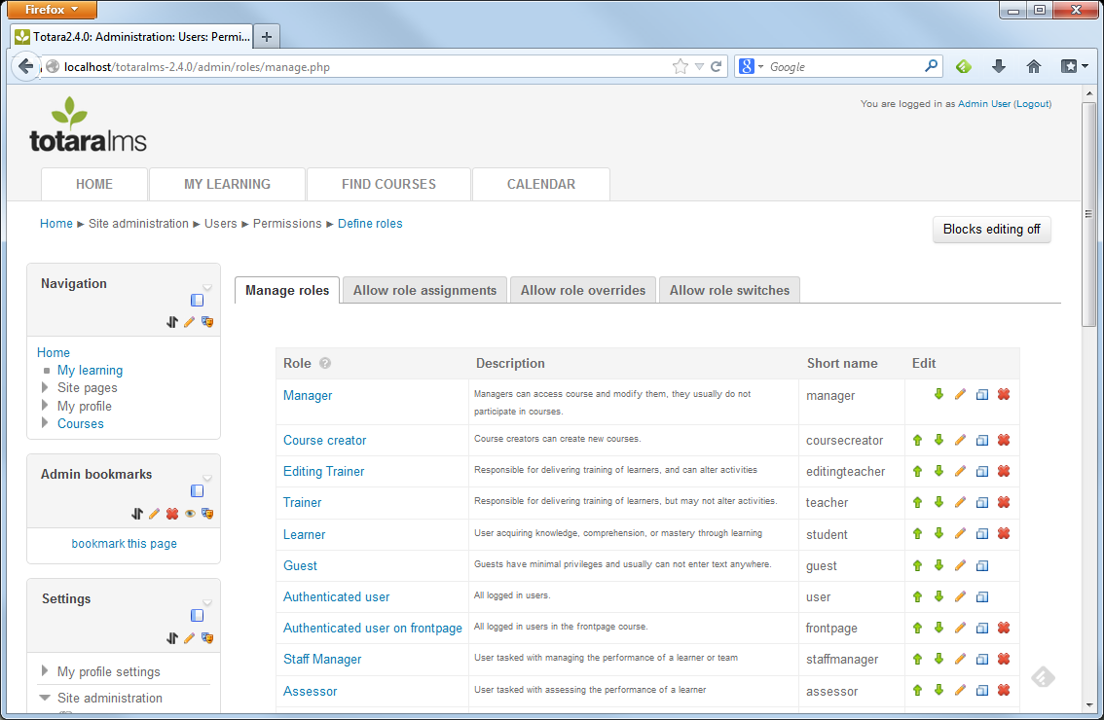
To view a particular role, click the role name. In this example, we will look at the capability permissions for the Trainer role. Click the Edit button to update permissions for a role.
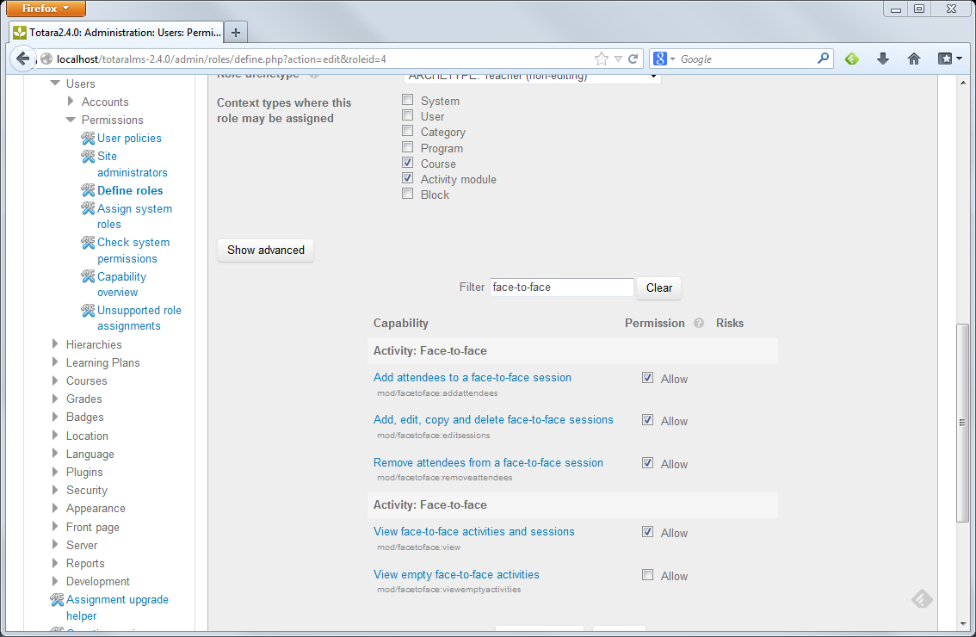
Capabilities are grouped based on the area or Context type; this could be System-level, User, Course Category, Program, Course, Activity or Block. Different roles can be assigned permissions for different context types; for example Course-specific roles like Trainer and Learner can be limited so that they may only be granted capabilities at the Course level.
Use the Filter box to search for the text “Face-to-face”. This will display capabilities for both the Face-to-face block and activity.
Place a tick in the Allow check box next to any capabilities that the user role should be permitted to access. In the case of the Learner, the only capability allowed by default is the ability to sign-up for a session.
Default Permissions include:

Learner
Sign-up for a session
Cancel booking for a session
Receive notifications

Manager
Receive copies of the learner notifications
Approve/deny learner’s request to sign-up for a session

Trainer
Create/edit a session in an existing activity
Sign-up/book attendees for a session
Approve/deny learner’s request to sign-up for a session
Message attendees
Take attendance

Editing Trainer & Course Creator
*In the context of a Face-to-face activity, these roles have the same level of permissions.
Create/edit a Face-to-face activity in the course page
Create/edit a session in an existing activity
Sign-up/book attendees for a session
Approve/deny learner’s request to sign-up for a session
Message attendees
Take attendance

Staff Manager & Regional Manager
*In the context of a Face-to-face activity, these roles have the same level of permissions.
Access reports displaying Face-to-face attendance data

Site Administrator
Manage site-wide activity settings
Manage site-wide notification templates
Build and grant access to reports

Action | Learner | Manager | Trainer | Editing Trainer | Course Creator | Staff Manager | Regional Manager | Site Administrator
Sign-up/cancel their own booking for a session | X | X | X | X | X | X | X | X
Book attendees |  |  | X | X | X |  |  | X
Message attendees |  |  | X | X | X |  |  | X
Create activity notifications |  |  |  | X | X |  |  | X
Take Attendance |  |  | X | X | X |  |  | X
Approve/deny booking request |  | X | X | X | X |  |  | X
Create/Edit a session |  |  | X | X | X |  |  | X
Create/Edit an activity |  |  |  | X | X |  |  | X
Build Reports |  |  |  |  |  |  |  | X
Manage site-wide activity settings |  |  |  |  |  |  |  | X
Manage site-wide notification templates |  |  |  |  |  |  |  | X
Access Reports | Any role may be granted permission to access a report that has been created for them by the Site Administrator.

Manage Site-wide Configuration Settings
Setting up the Face-to-face activity requires multiple steps that can be performed by users with the most appropriate roles. Configuration steps include:
- Enable the activity at a site-wide level to make it available for use in the course page (one-time setup)
- Manage settings that will impact activities across the site page (one-time setup)
- Set up the Face-to-face activity in the course page
- Set up individual sessions within the activity including the date, time, location and trainer

Enable Face-to-face Activities
To enable the Face-to-face activity, Site Administrators can go to the Settings block and click on Site Administration > Plugins > Activity Modules > Manage activities.
Click the Hide/Show icon next to Face-to-face activity so that the eye icon appears to be open.
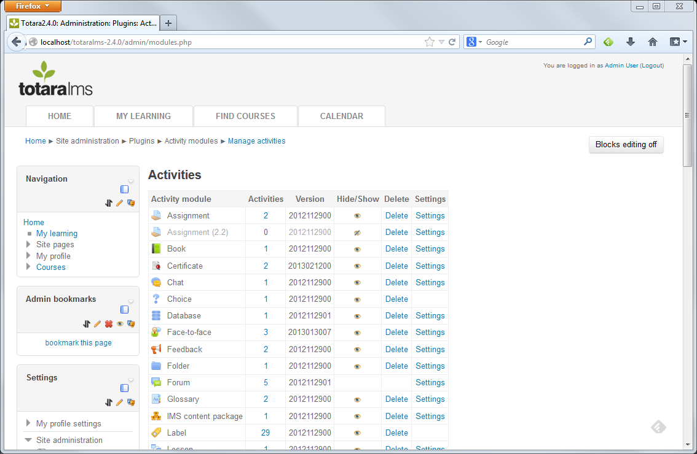

Manage Face-to-face Activity Settings
To manage Face-to-face activity settings, Site Administrators can click the Settings link next to Face-to-face. You can also access these settings in the Settings block under Site Administration > Plugins > Activity Modules > Face-to-face.
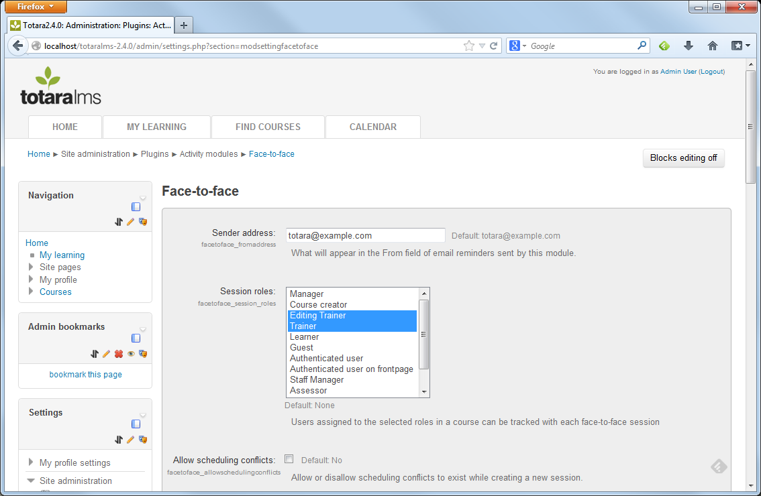

General Settings
Sender Address: Enter the email address that will appear in the From field of email reminders sent by this module.
Session roles: The roles selected here will create a list at the bottom of the session settings page, so that the Trainer setting up the session can select the trainer(s) who will be associated with the session.
Allow scheduling conflicts: Allow or disallow scheduling conflicts to exist while creating a new session. If a trainer in the Session Roles area has already been scheduled for another session at the same date/time, the activity will display an alert that there is a scheduling conflict for that user.

Manager Emails
Notification messages can be sent to a learner’s manager as well. In some cases, there may not be a Manager associated with the learner’s profile. The following settings allow the learner to enter a manager’s email address for receipt of notifications.
Manager’s email: Check this option to ask users for their manager’s email address when they are signing up for a session.
Required suffix: Suffix which must be present in the email address of the manager in order to be considered valid.
Format example: If the Required Suffix field is set, then enter a sample of the format the Manager’s email will be in.

Session Cost
A session may have a cost or fee associated with it. This information can be displayed on reports in order to track training costs. The following options allow the Site Administrator to hide the cost and discount cost fields from the session creation page, if they will not be in use.
Hide cost and discount: Hide the cost and discount code fields if they are not used in Face-to-face sessions.
Hide discount: Hide only the discount field if it is not going to be used in Face-to-face sessions.

iCalendar Attachments
Along with email notifications, the Face-to-face activity can also send out iCal attachments so that learners can add their training events to their Outlook or Google Calendar.
One message per day: Checking this option will send an individual notification message and iCal attachment for each day of a multi-day Face-to-face session. This option needs to be enabled for Outlook calendar users; otherwise only one iCal notification will be sent for the entire date range.
Disable iCalendar cancellations: Disable sending cancellation iCal attachments.
If any of the values in the previous fields have been changed, be sure to scroll to the bottom of the page and click the Save changes button.

Custom Session Fields
If additional information about Face-to-face sessions needs to be captured, the Site Administrator can setup additional custom fields that will be completed by the Trainer as part of the session setup. Go to the Settings block and under Site Administration > Plugins > Activity Modules > Face-to-face click on Create a new custom field.
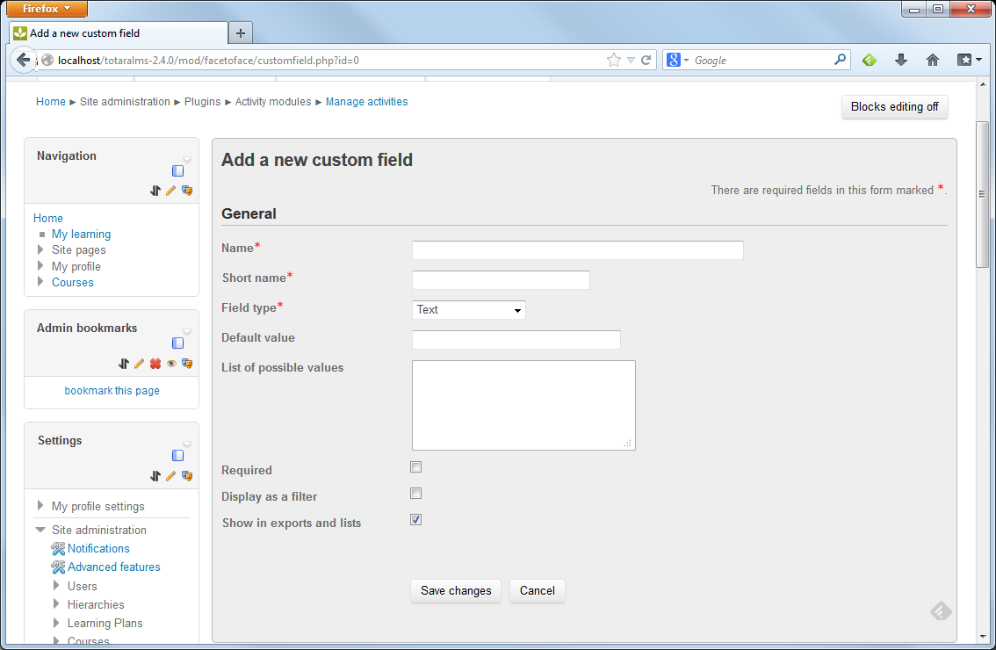
Name: Enter the full name of the field that will appear in the Face-to-face session settings.
Short Name: Enter a short name for the new field.
Field Type: Select the type of field that will be created. Does the session creator need to enter Text, choose a single answer from a Menu of Choices or choose multiple answers from a Multiple Selection field?
Default value: Enter the default value for the field, if needed. If this will be a Menu of Choices or Multiple Selection field, the default value will be added to the list of possible choices automatically.
List of possible values: If the Field Type is set to Menu of Choices or Multiple Selection, enter the list of choices that the session creator can choose from. List each option on its own line.
Required: Select whether this field must be filled out when the session is created or leave this option unchecked to make it an optional field.
Display as a filter: This field can appear as a filter on reports so that you can search report results for sessions with particular values. Choose whether to display this field as an option in Report Filters.
Show in exports and lists: Make the data from this field available to reporting.

Site Notices
Site notices are messages that can be displayed in the Face-to-face block calendar. Notices will appear when a session is setup with particular values from the Custom Session fields.
To enable the Face-to-face calendar that will display Site Notices, update the main Navigation Calendar with the following link:
http://your domain/blocks/facetoface/calendar.php
The link can also be added to the site by creating a new HTML block in the course page and inserting the link above. The Face-to-face calendar is shown below with the Site Notice “Please note that this session is mandatory for all learners. Please be sure to sign up for a session.”

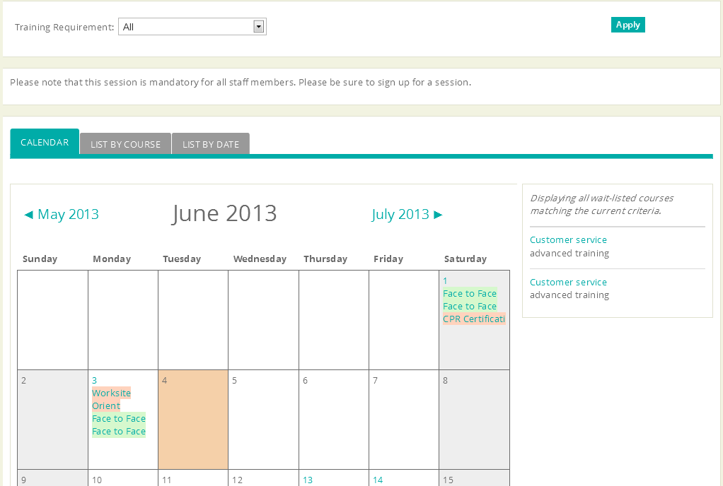
To add a new site notice, go to the Settings block and under Site Administration > Plugins > Activity Modules > Face-to-face click on Create a new site notice.
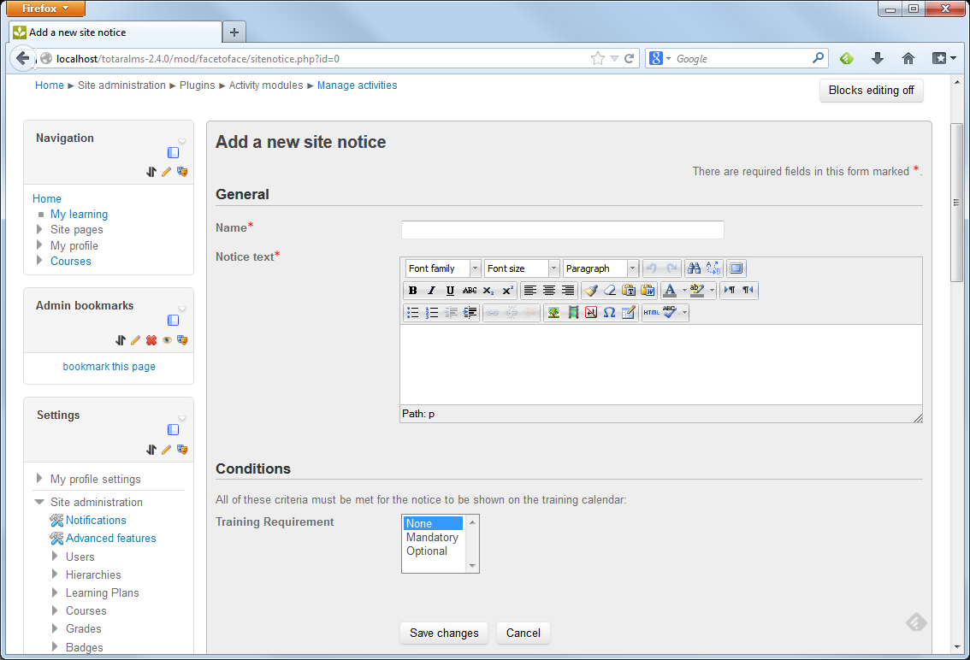
Name: Enter a name for the notice that will be displayed on the calendar.
Notice text: Enter the text that will appear when a user clicks on the notice in the calendar.
Conditions: Select the values from the custom session fields that will trigger this notice to be displayed on the calendar.
Click the Save Changes button. When the conditions of the notice are met within a session’s settings, the notice will be displayed on the calendar.

Notification Templates
An administrator can create email or message templates to be used by course creators and/or instructors with messaging privileges. These message templates can be used as is, or modified by the message author at the time the message is being created.
To manage site-wide templates, a Site Administrator can go to the Settings block and under Site Administration > Plugins > Activity Modules > Face-to-face click on Manage notification templates.
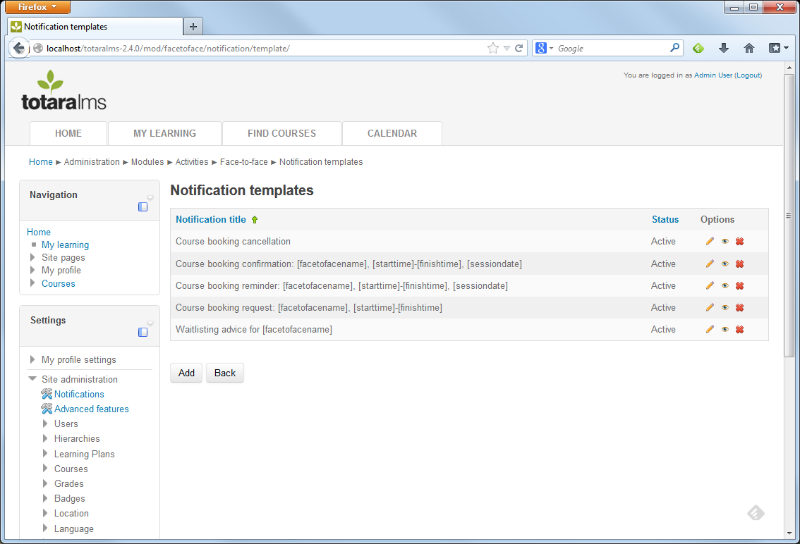
Auto-populated notifications are hard coded into Totara and will pre-populate in every F2F activity's notification list, in order to save time for the course creator. Their body content can be edited, if required, or they can be made 'inactive' if they are not needed. This default set includes:
- Course booking confirmation: Confirms that the user is booked for the session.
- Course booking cancelled: Alerts the user that the session has been cancelled.
- Course booking date/time changed: Advises the user of the new date and time of the session.
- Course booking reminder: Reminds user of their upcoming session. The reminder is scheduled within the individual Face-to-face activity.
- Course booking request: Alerts learner and manager that the session has been requested and allows the manager to approve the request.
- Course session trainer cancellation: Alerts the trainer that the session has been cancelled.
- Course session trainer unassigned: Alerts the session trainer that they have been unassigned as the session trainer.
- Course trainer confirmation: Confirms that the user is booked as the session trainer.
- Waitlisting advice: Alerts the user that the session is full and that they are on a waitlist for the session.
The existing notifications will be listed including the notification title and whether it is active and available to session creators for use in a course session. Additional options include Editing the notification (pencil icon), Deactivating it (eye icon) or Deleting it (“X” icon).
To add a new notification, click the Add button.
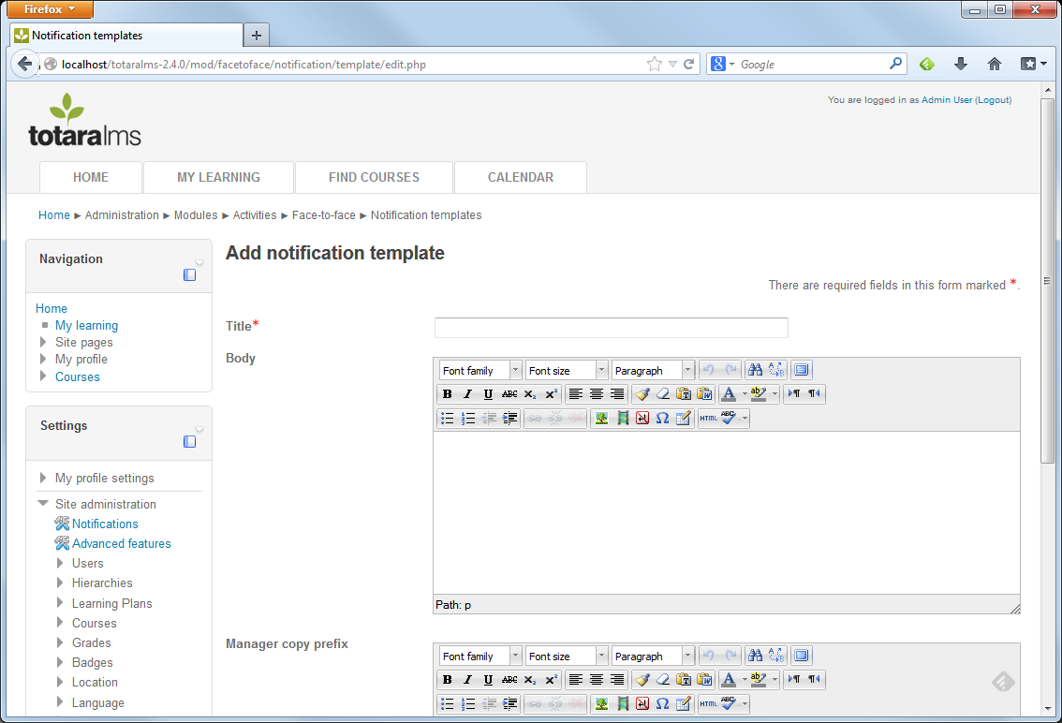
Title: Enter the title of the notification, which will also be used as the email subject line.
Body: Enter the notification message. This will be used as the email body. Variables can be inserted that will autopopulate with the specific session and user’s details. The following variables are available:
- [facetofacename]: Name of the Face-to-face activity
- [sessiondate]: The individual session date that the user is booked for
- [alldates]: Dates from each of the face-to-face activity sessions
- [starttime]: The session start time
- [finishtime]: The session end time
- [cost]: The cost/fee for the session
- [duration]: The expected duration of the session
- [session:location]: The location entered for this session
- [session:venue]: The venue or building the session will be held in
- [session:room] The room name or number that the session will be held in
- [details]: Additional details added to the session description
- [reminderperiod]: The amount of time prior to the event that the user will receive a reminder
- [firstname]: The user’s first name
- [lastname] The user’s last name
For example, to send users a confirmation email that says:
Subject line: Course booking confirmation: CPR Certification, 10:00 AM-3:00 PM, 1 May 2013
This is to confirm that you are now booked on the following course:
Participant: Sample Learner
Course: CPR Certification
Date(s):
1 May 2013, 10:00 AM to 3:00 PM
Location: LA Campus
Venue: Waits Building
Room: Meeting Room A

Setup the following template, which is based on the default Course Booking Confirmation:
Notification Title: Course booking confirmation: [facetofacename], [starttime]-[finishtime], [sessiondate]
This is to confirm that you are now booked on the following course:
Participant[firstname] [lastname]
Course: [facetofacename]
Date(s):
[alldates]
Location: [session:location]
Venue: [session:venue]
Room: [session:room]

Manager copy prefix: Enter any additional information that will be sent to the learner’s manager.
Status: An active notification template is one that is available to session creators to use in their sessions.

Room Management
Face-to-face (F2F) session creators may choose a meeting location type of either a Predefined room or a Custom room. Both room types will have the following attributes:
• Room name
• Building name
• Address – the room/building physical street address
• Capacity – the seating capacity for the room

Predefined Room- A predefined room is a room defined within the system that can be assigned to F2F sessions. When creating a new Face-to-face session (and in selecting ‘Predefined room’ as the meeting location), a list of predefined rooms will appear to the session creator. Only predefined rooms available for the date/time defined will be selectable (via a checkbox). In selecting a predefined room, basic conflict management occurs to ensure that the room is available for the date/time selected.
To add a new predefined room, Site Administrators can go to the Settings block and under Site Administration > Plugins > Activity Modules > Face-to-face click on Manage Rooms.
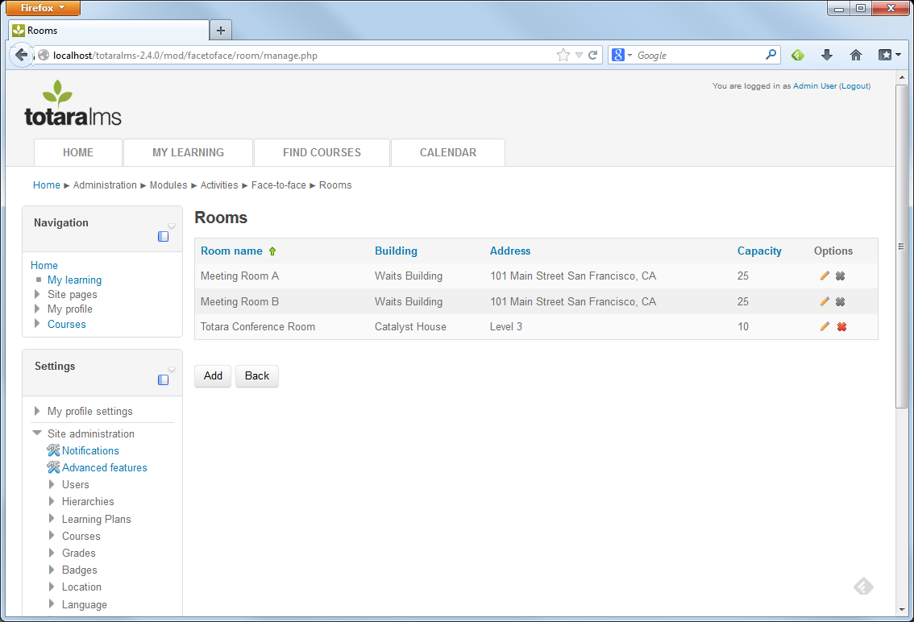
A list of existing rooms will be displayed, including the Room name, Building, Address and Capacity. Under the Options column, click the Edit button to edit an existing room or the Delete button to remove a room.
To add a new room, click the Add button.
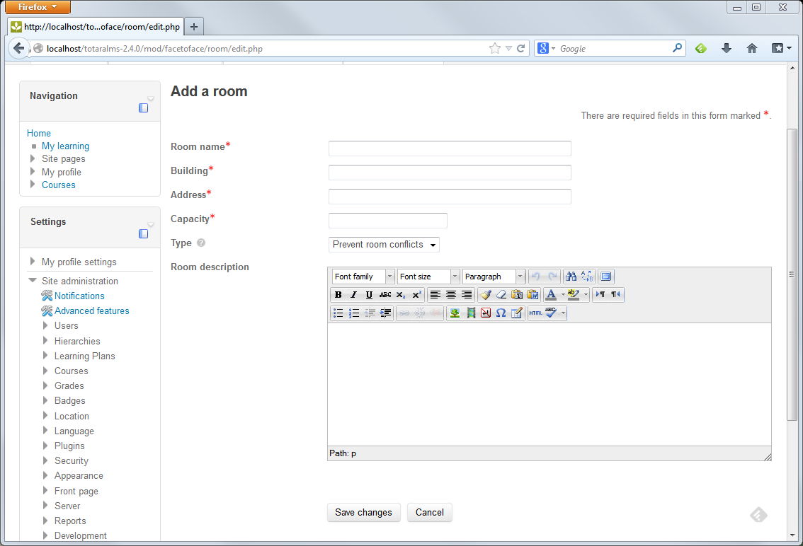
Room name: Enter a name for this room.
Building: Enter the name of the building or venue that the room is in.
Address: Enter the street address of the room.
Capacity: Enter the number of people that this room can hold.
Type: The room type is used to determine if the system should try and prevent room booking conflicts. This will prevent a room from being booked for 2 sessions that are running at the same time.
Room description: Enter a description of the room if needed.
Click the Save changes button. Once this room is saved, it will be available to Face-to-face session creators when they are creating a session.

Configure Site-wide Face-to-face Session Reports
Face-to-face information including activity, session and attendance details can be included on custom reports built in the Report Builder. Site Administrators can build custom reports and make the reports available to other users based on their role.
To create a new Face-to-face report, Site Administrators can go to the Settings block and under Site Administration > Reports > Report Builder > Manage Reports.
Select the Report Source “Face-to-face sessions”. Column data and filters available in this source includes:
Session Data: Capacity, number of attendees, details, duration, discount code, normal cost, discount cost, cancellation date and reason
Status: Learner’s booking and attendance status (booked, wait-listed, cancelled, fully attended, partially attended, no show)
Face-to-face name: Name of the Face-to-face activity, link to the activity
User Profile fields: All fields from the user profile, such as the learner’s name, email address, position and organization are available as well as any custom user profile fields
Course Data: Course-level fields such as the course name, link to the course, shortname, ID, summary
Category: Course category information including name, a link to the category and ID
Tags: View the tags associated with the course by selecting specific tags or selecting “Tags” which will include a list of all of the tags for this course
Custom Organization and Position fields: Any custom fields that were setup for organizations

Course Creator Workflow
Creating a new instructor led training session with the Face-to-face activity is a two-step process. First, the Face-to-face activity is created in the course page by an Editing Trainer or Course Creator. Second, the individual Face-to-face sessions are scheduled by an Editing Trainer or Trainer.

Create a Face-to-face Activity
Editing Trainers or Course Creators can navigate to the course page and click the Turn editing on button.
Click the Add an activity or resource link.
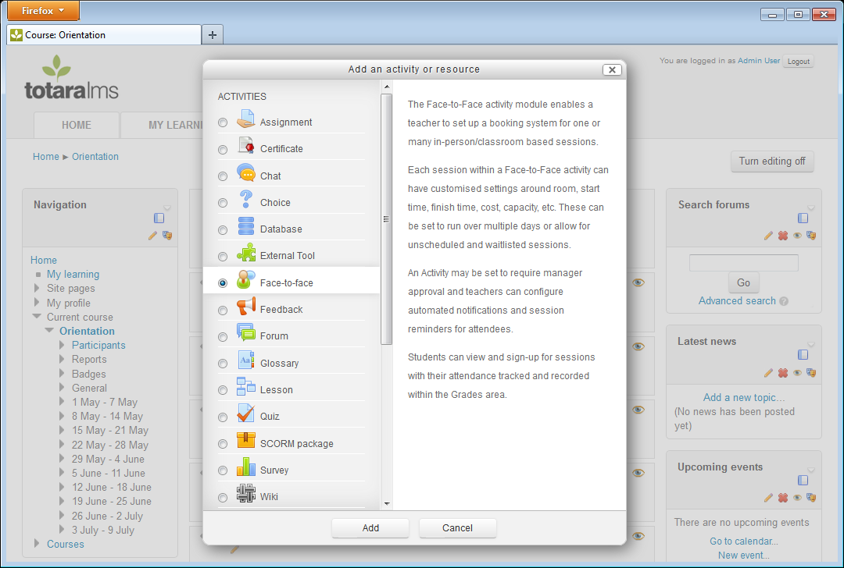
Select Face-to-face and click the Ok button.
Enter the following settings for the Face-to-face activity.
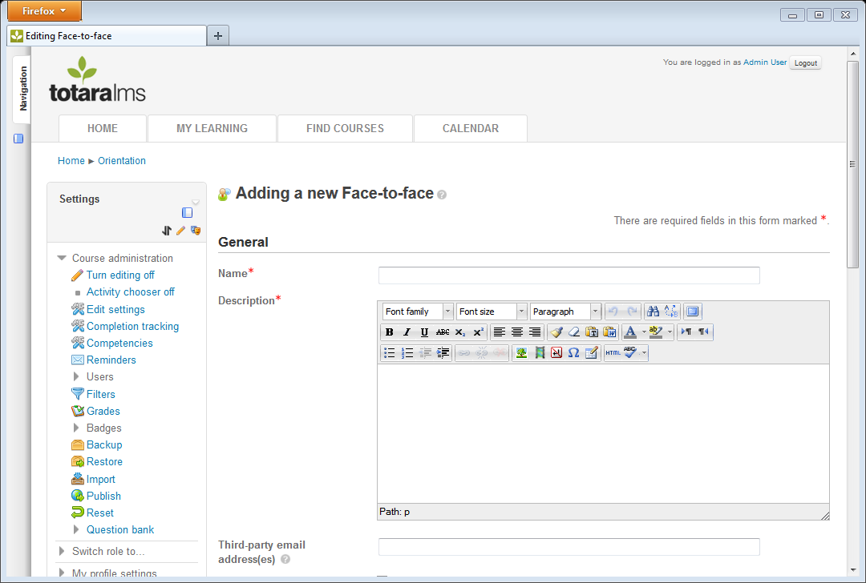
Name: Enter a name for the activity e.g. CPR Certification Course.
Description: Enter a description for the activity.
Third-party email address(es): Third-party email address(es) is an optional field used to specify the email address of a third-party (such as an external instructor) who will then receive confirmation messages whenever a user signs-up for a session. When entering multiple email addresses, separate each address with a comma. For example: bob@example.com,joe@example.com
Notify third-party about wait-listed sessions: Enabling this option will send third-party email address(es) a notification when a learner signs up for a wait-listed session. If this option is disabled, the third party will only receive notifications when a user is confirmed or cancelled for a session.
Sessions displayed on course page: This is the number of sessions for each face-to-face activity that will be shown on the main course page.
Approval required: When "Approval required" is checked, a learner will need approval from their manager to be permitted to attend a face-to-face session.
Calendar display settings: Choose whether this activity’s sessions will appear on the Site calendar for all users to see, on the course calendar so that it is only visible to users enrolled in this course, or if it will not appear on the calendar.
Show entry on user’s calendar: When active this setting adds a User Event entry to the calendar of an attendee of a face-to-face session. When turned off this prevents a duplicate event appearing in a session attendee's calendar, where you have calendar display settings set to Course or Site.
Short name: The description of the session that appears on the training calendar when Show on the calendar is enabled.
Group mode: Choose whether this activity is limited to course groups.
“No Groups” makes everyone a part of one course-wide community.
“Separate groups” prevent users from seeing users outside of their own group.
“Visible groups” allow users to work in their own group but see other groups as well.
Visible: When an activity is marked visible, learners will see it on the course page.
ID Number: Setting an ID number provides a way of identifying the activity for grade calculation purposes.
Completion Tracking: Choose if and how this activity will be marked as complete. This option needs to be enabled if attendance of a face-to-face session is a requirement for course completion. Learners can manually mark items as complete using a checkbox next to the item on the course page, the activity can be marked as automatically complete based on criteria you specify or this activity can be left out of completion tracking.
Require view: If you have enabled the “Show activity as complete when conditions are met” option for Completion tracking, choose whether viewing the activity (clicking the link to view it) is considered a requirement for completion tracking.
Require grade: If you have enabled the “Show activity as complete when conditions are met” option for Completion tracking, choose whether the trainer entering the learner’s attendance status is considered a requirement for completion tracking.
Expect completed on: This setting specifies the date when the activity is expected to be completed. The date is not shown to students and is only displayed in the activity completion report.
Click the Save and display option to view the Face-to-face activity.
The Face-to-face activity is displayed.
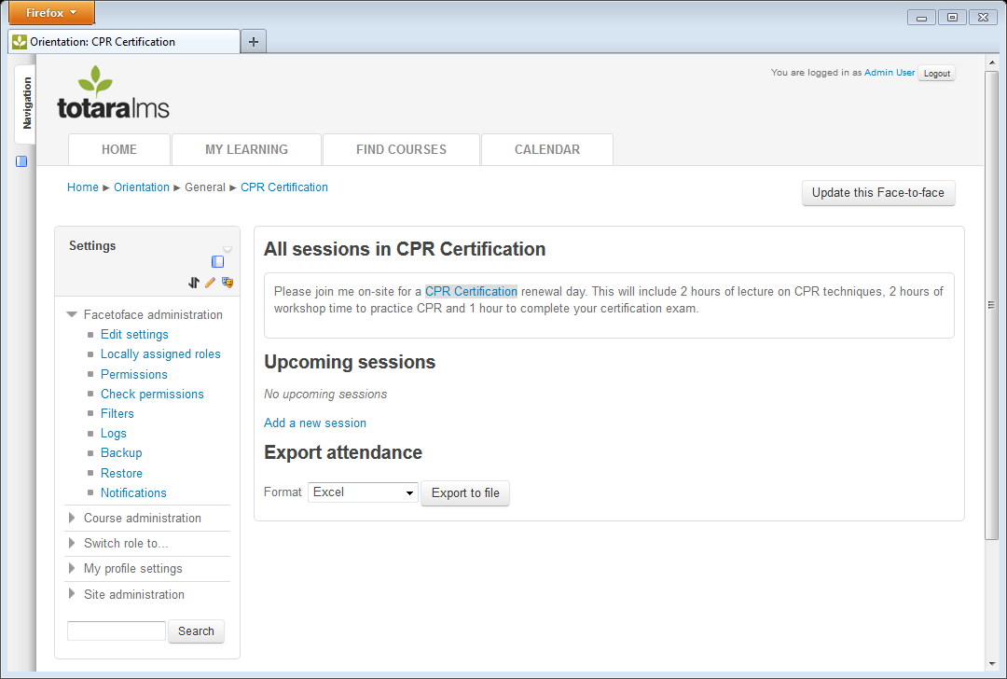

Manage Activity Notifications
Face-to-face notifications are email messages that Totara will send based on certain events, such as a confirmation that the learner is booked for a session, a notice that the date/time of a session has changed, or a session having been cancelled. Notifications can also be sent to the learner’s manager to approve a request to attend a session or to provide information about a session that a learner has signed up for.
To access notifications, choose a Face-to-face activity and in the Settings block, go to Facetoface administration > Notifications.

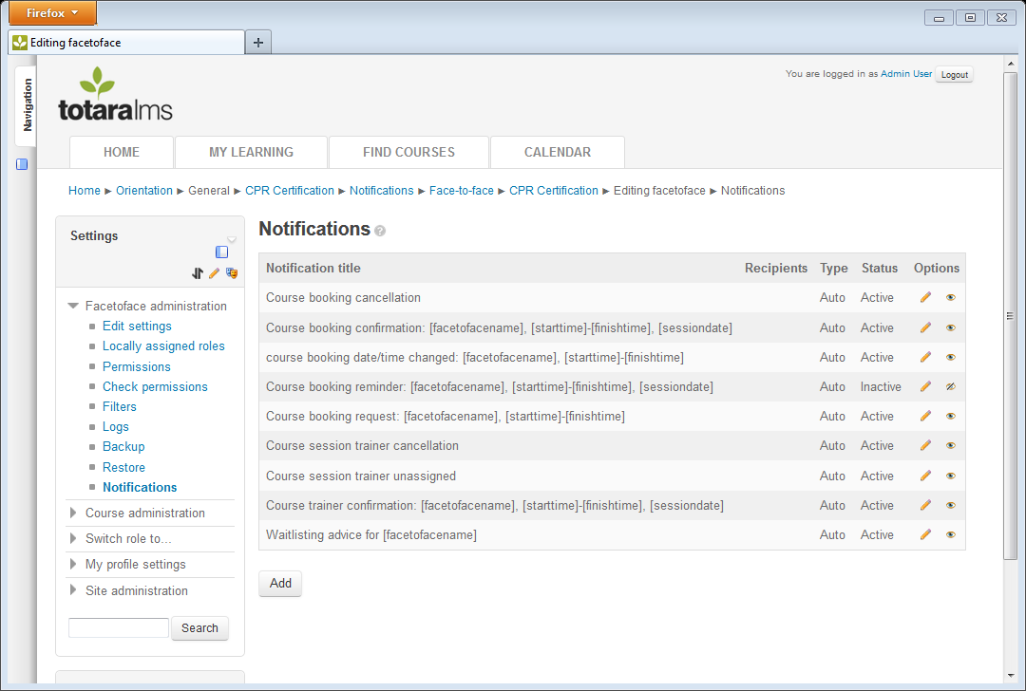
A set of auto-populated notifications are hard coded into Totara and will pre-populate in every FACE-TO-FACE activity's notification list, in order to save time for the course creator. Their body content can be edited, if required, or they can be made 'inactive' if they are not needed. This default set includes:
- Course booking confirmation: Confirms that the user is booked for the session.
- Course booking cancelled: Alerts the user that the session has been cancelled.
- Course booking date/time changed: Advises the user of the new date and time of the session.
- Course booking reminder: Reminds user of their upcoming session.
- Course booking request: Alerts learner and manager that the session has been requested and allows the manager to approve the request.
- Course session trainer cancellation: Alerts the session trainer that the session has been cancelled.
- Course session trainer unassigned: Alerts the session trainer that they have been unassigned as the session trainer.
- Course trainer confirmation: Confirms that the user is booked as the session trainer.
- Waitlisting advice: Alerts the user that the session is full and that they are on a waitlist for the session.
The existing notifications will be listed including:
- Notification title: The name of the notification and subject line for the notification email.
- Recipients: Who will receive the notifications (All booked, all wait-listed, etc.)
- Type: Whether this notification is sent immediately upon some event (e.g. booking confirmation sent as soon as the learner signs up) or if it is scheduled (e.g. a reminder sent two days prior to the session)
- Status: An “Active” notification is in use and may be sent to users. An “Inactive” notification will not be sent to users.

Additional options include editing the notification (pencil icon) or deactivating it (eye icon) so that it is not sent to users.
To add a new notification, click the Add button.
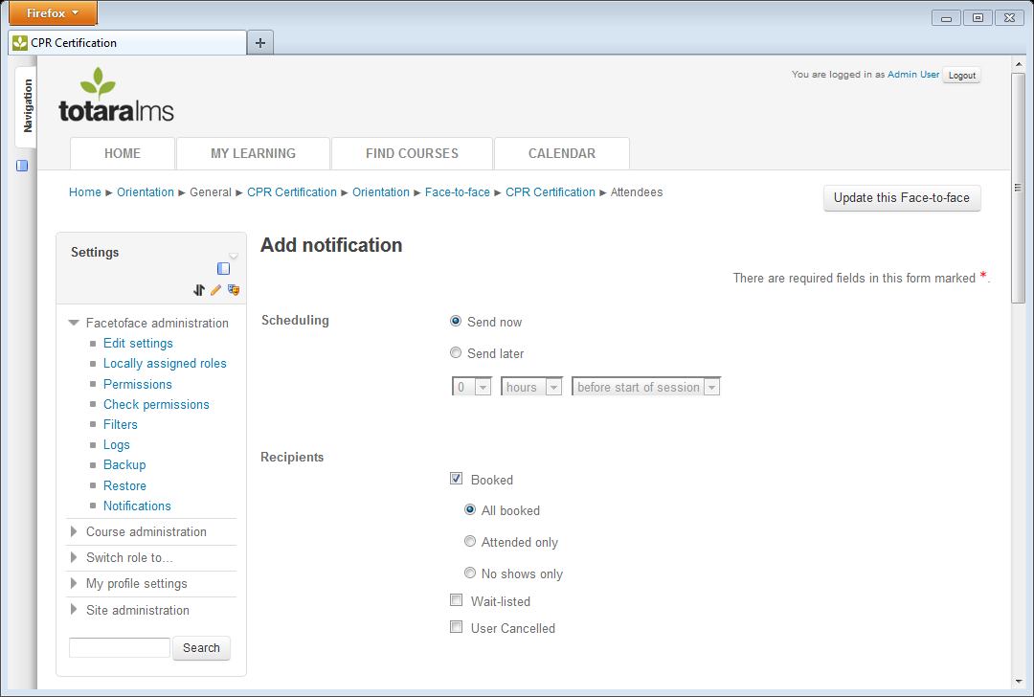
Scheduling: Choose whether the notification should be sent immediately (Send now) based on the event that has occurred (e.g. confirmation of booking) or if it should be scheduled (Send Later). If Send Later is selected, enter the number of hours, days or weeks before the start or after the end of the session that the notification should be sent.
Recipients: Select who should receive the notification based on their booked status and attendance. Selecting Booked allows you to send the notification to all users who were booked, only those who attended, or only those who did not attend. Wait-listed users are those who signed up for a full session that allowed overbooking, but were not fully booked. User cancelled will send a message to users for whom the session was cancelled or who removed themselves from the session.
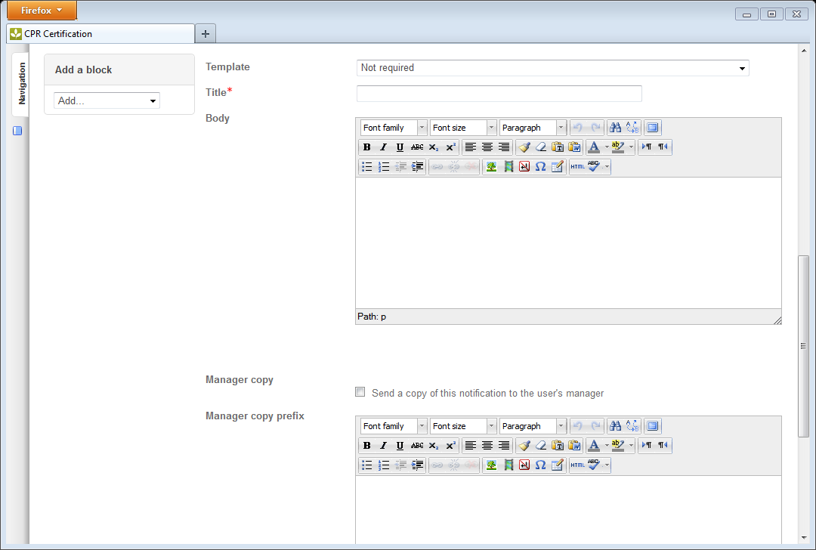
Next enter the message that the users will receive.
Template: Select one of the notification templates to autopopulate the Title, Body and Manager copy prefix. The selection can then be customized for this Face-to-face activity.
Title: Enter the title of the notification, which will also be used as the email subject line.
Body: Enter the notification message. This will be used as the email body.
Variables can be inserted in the Title and Body that will autopopulate with the specific session and user’s details. The following variables are available:
- [facetofacename]: Name of the Face-to-face activity
- [sessiondate]: The individual session date that the user is booked for
- [alldates]: Dates from each of the face-to-face activity sessions
- [starttime]: The session start time
- [finishtime]: The session end time
- [cost]: The cost/fee for the session
- [duration]: The expected duration of the session
- [session:location]: The location entered for this session
- [session:venue]: The venue or building the session will be held in
- [session:room] The room name or number that the session will be held in
- [details]: Additional details added to the session description
- [reminderperiod]: The amount of time prior to the event that the user will receive a reminder
- [firstname]: The user’s first name
- [lastname] The user’s last name
For example, to send users a confirmation email that says:
Subject line: Course booking confirmation: CPR Certification, 10:00 AM-3:00 PM, 1 May 2013
This is to confirm that you are now booked on the following course:
Participant: Sample Learner
Course: CPR Certification
Date(s):
1 May 2013, 10:00 AM to 3:00 PM
Location: LA Campus
Venue: Waits Building
Room: Meeting Room A

Setup the following notification, which is based on the default Course Booking Confirmation:
Notification Title: Course booking confirmation: [facetofacename], [starttime]-[finishtime], [sessiondate]
This is to confirm that you are now booked on the following course:
Participant[firstname] [lastname]
Course: [facetofacename]
Date(s):
[alldates]
Location: [session:location]
Venue: [session:venue]
Room: [session:room]

Manager copy: Tick the check box to send a copy of this notification to the user’s manager.
Manager copy prefix: Enter any additional information that will be sent to the learner’s manager along with the message that the learner received.
Status: Tick the Status check box to make this notification active in the Face-to-face activity, meaning that learners and potentially their managers will be sent the notification when appropriate.
Click the Save button to save any changes.
Once a notification is made Active and Recipients are selected, Totara will automatically send notifications immediately after an event occurring (e.g. booking confirmation) or based on the schedule selected (e.g. reminder sent 2 days before session).

Session Manager Workflow

Create a New Session
After adding the Face-to-face activity to the course page, sessions need to be created that contain the specific date, time and location for the instructor-led training.
To add a new session to the Face-to-face activity, click the Add a new session link.
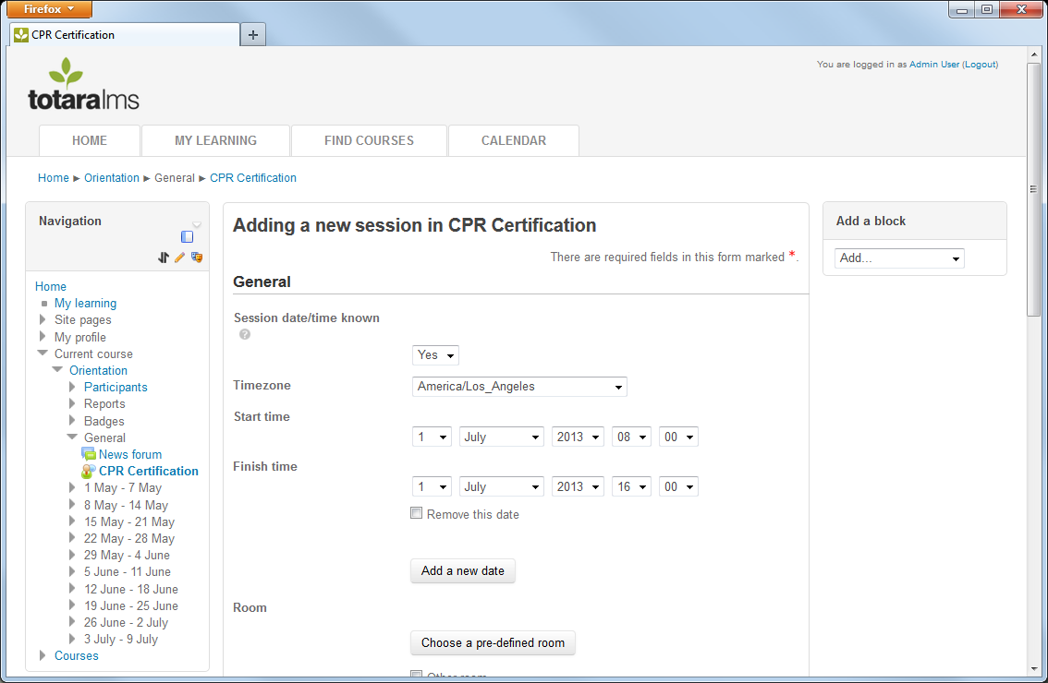
Enter the following details for the session.
Session date/time known: Choose “Yes” if there is a known date and time for the session.
If “Yes” is selected, the learner and manager will be sent a confirmation email notification as well as a reminder message before the session.
If “No” is selected, the session will display the text “wait-listed” on the course page, the learner will receive the wait-listed email notification, the learner will not be sent a reminder email and the learner’s manager will not receive a confirmation or cancellation email notification for this session.
Timezone: Select the Timezone that the session dates and times will be based on. This timezone will default to the one setup in Site Administration > Location > Location Settings.
Start time: Enter the starting date/time including the date, month, year, hour and minute.
Finish time: Enter the ending date/time including the date, month, year, hour and minute.
To add a second session, click the Add a new date button. If any details aside from the date and time will differ from the first session, then don’t use this option. Additional sessions with varying details can be added via the Add a new session link on the activity page.
Enter the location of the session by choosing a pre-defined room or by entering a location.
Click the Choose a pre-defined room option to select a room from a list of options created by the Site Administrator. Note that if the Session date/time known option is set to “No”, the Choose a pre-defined room button will be greyed out to prevent scheduling conflicts.
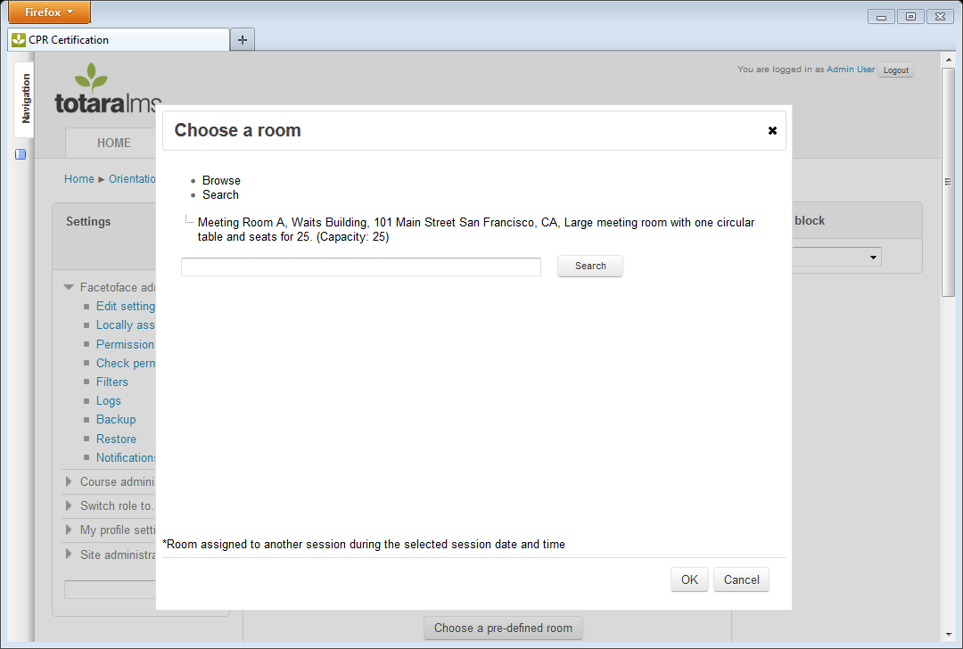
If a room has been assigned to another session during the selected session date and time, it may have an asterisk next to it and will not be available for selection. This is to prevent scheduling conflicts.
To add details for a room that is not on the list, tick the Other room box and enter the Room name, Building and Address in the text boxes provided.
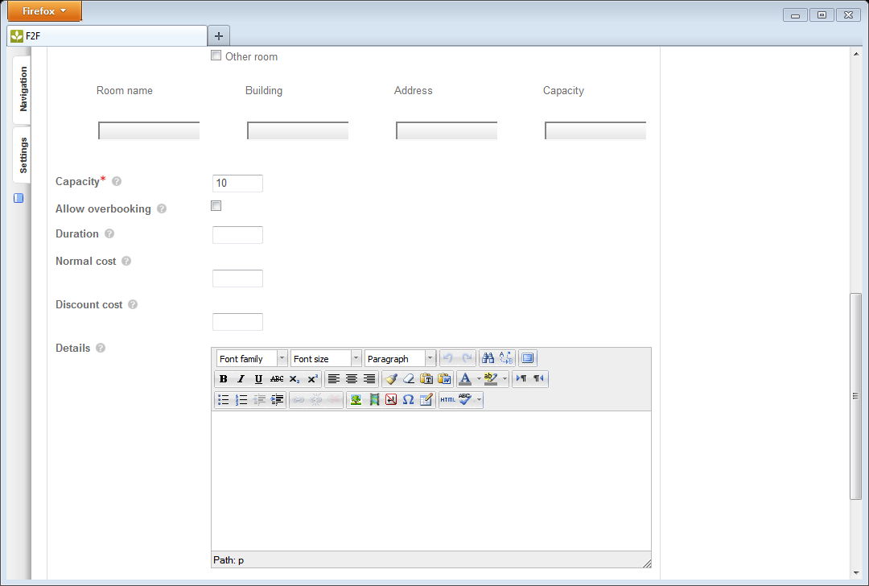
Capacity: Enter the number of seats available in a session.
When a face-to-face session reaches capacity the session details do not appear on the course page. The details will appear greyed out on the 'View all sessions' page and the learner cannot enroll on the session.
Allow overbooking: When checked, learners will be able to sign up for a face-to-face session even if it is already full.
When a learner signs up for a session that is already full, they will receive an email advising that they have been waitlisted for the session and will be notified when a booking becomes available.
Duration: Enter the total length of the training in hours. For example:
"2 hours" is enters as 2 or 2:00
"1 hour and 30 minutes" is entered as 1:30
"45 minutes" is entered as 0:45
If the training occurs over two or more time periods, the duration is the combined total.
Normal cost: Normal cost is the dollar amount charged to learners who do not have a membership id. The normal cost will appear in the cost column in the course's gradebook for each learner who attends the session (unless a discount cost is entered and the learner enters a membership id when signing of the session).
Discount cost: Enter the dollar amount charged to learners who have a membership id. If a learner enters a membership id when signing-up for a session, the discount cost will appear in the cost column in the course's gradebook. Note that if a discount cost is entered, the learner will be required to enter a Discount Code when signing up for a session.
Details: Details are tracked per session basis. If text is populated in the details field, the details text will be displayed on the user signup page. By default, the details text also appears in the confirmation, reminder, waitlist and cancellation email messages.
Session Roles: Select the trainer(s) that need to be scheduled for this session. When saving the session, the system will check to see if the trainers selected are already scheduled for a session at the same date/time. If a scheduling conflict occurs, a message containing information about the conflicting session will appear.
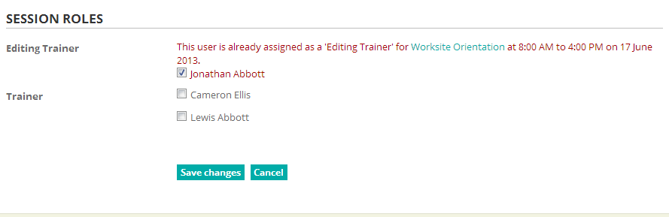
Click the Save Changes button to save the session.
The new Face-to-face session details will appear on the course page.
Note: If you click the Save Changes button and are taken to the back to the session settings page, scroll through the page to make sure there are no missing fields or schedule conflict alerts as shown above. If a scheduling conflict has been found, you must resolve that conflict by unchecking the selected trainer and clicking the Save Changes button again; otherwise the session will not be saved.

Clone an Existing Session
To create multiple sessions with similar details, use the clone option. Click on the Copy icon in the Options section next to a session.
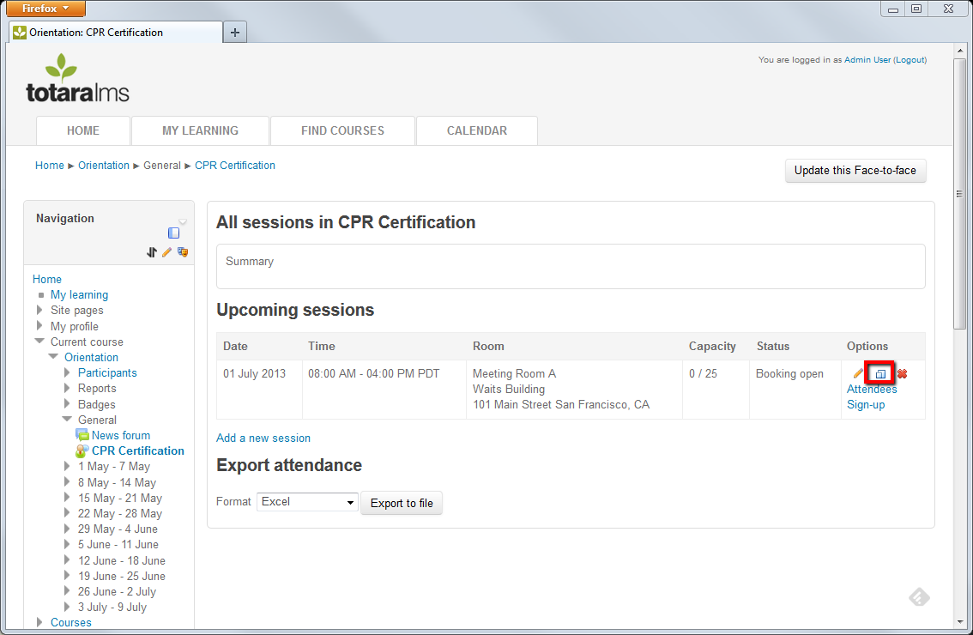
Update any details of the new session required, such as changing the date and time or the room details. Scroll to the bottom of the page and click Save Changes.

Book Attendees for a Session
Course creators and Trainers can book groups of attendees for a session using bulk user tools.
To book a group of users for a session, click on the Face-to-face activity name in the course page or the View All Sessions link. 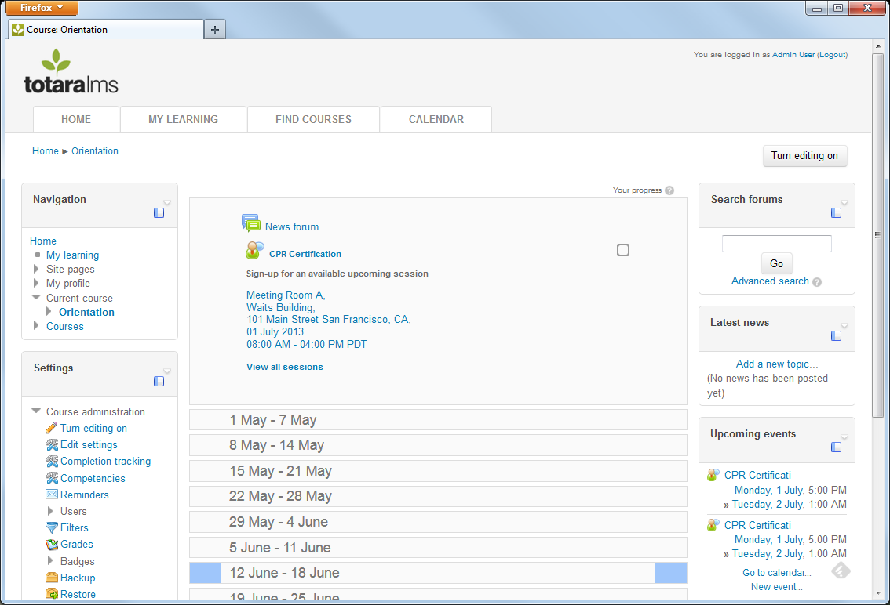
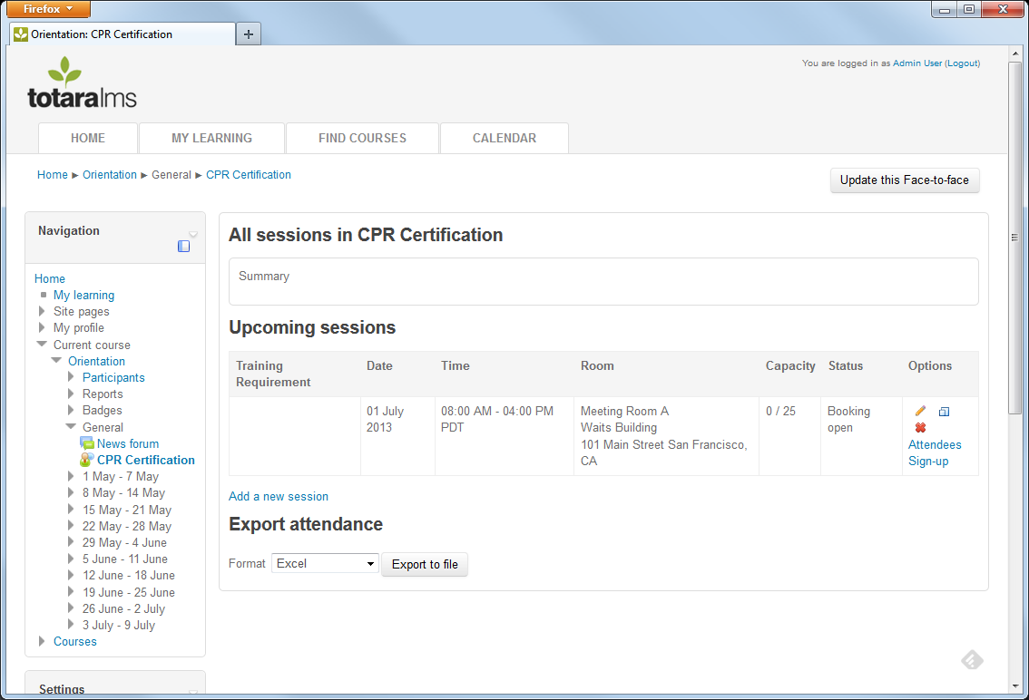
Click on the Attendees link next to the session you wish to book attendees into.
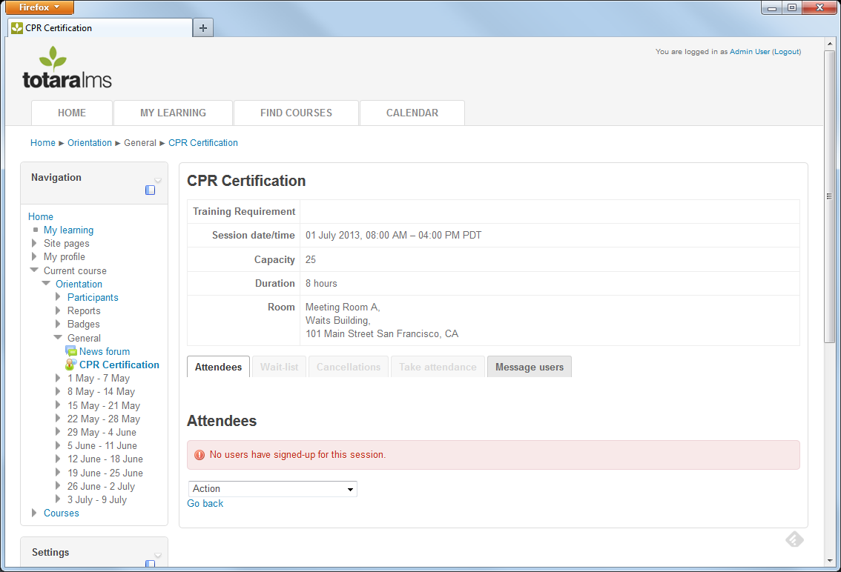
On the Attendees tab, click on the Action dropdown at the bottom of the page. Options for adding attendees include:
- Add/remove attendees: Manually add and remove attendees by clicking on their names.
- Bulk add attendees from file: Upload a file that contains the user idnumbers for attendees. This idnumber can be found on the User Profile in the ID number field.
- Build add attendees from text input: Type the user idnumbers directly into Totara.
You can mix and match these methods as needed.
Add/remove attendees: Manually add and remove attendees by clicking on their name(s) in a multiple select list on the right. Click the Add button to move them to the left column. Click the Save button.
To prevent attendees from receiving confirmation and/or cancellation emails from this action, check the Suppress the confirmation and calendar invite emails for newly added attendees and the cancellation emails for removed attendees option.
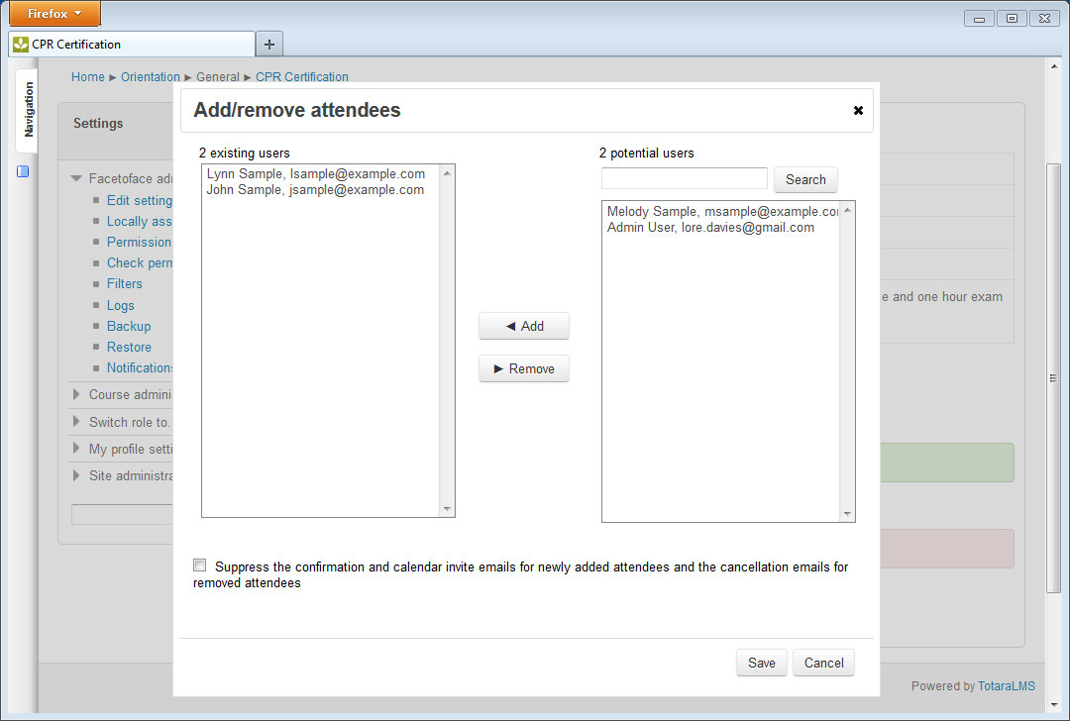
Bulk add attendees from file: Upload a file that contains the idnumber for each attendee. Each idnumber needs to be on a separate line and followed by a new line. Following is a sample file:
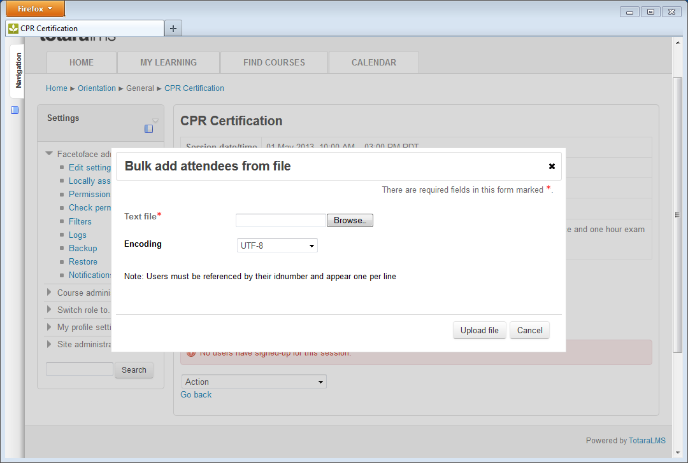
Click the Browse button and use the Browse window that appears to find the file. Click the Open button.
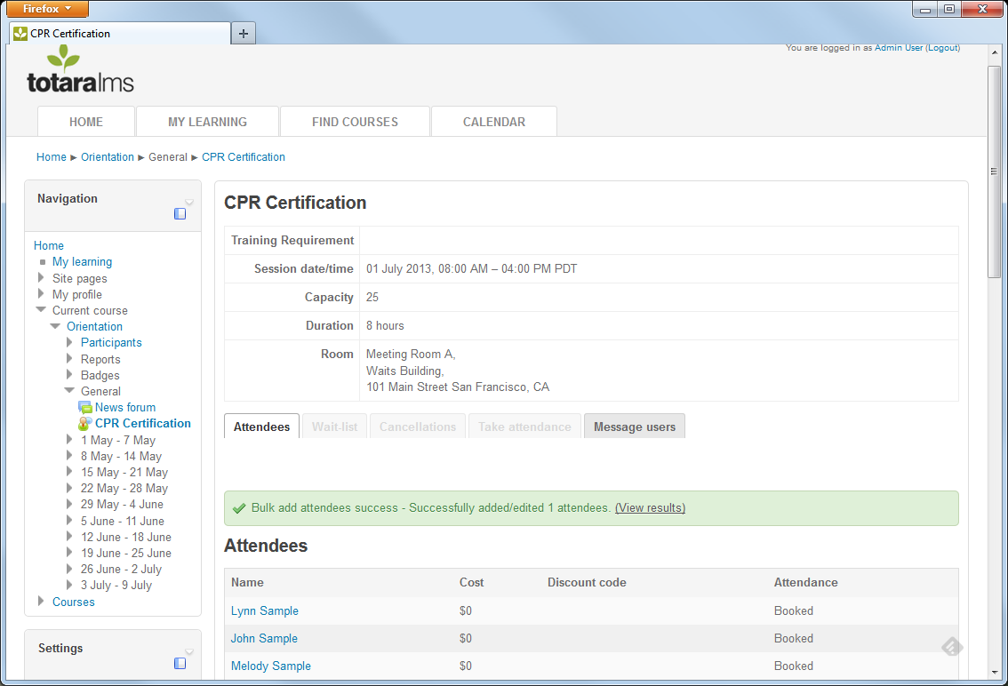
Select the file Encoding and then click the Upload file button. After the file has been processed, a message will appear that shows whether the upload was successful. Click the View results link to get more information about which attendees were successfully added or encountered errors.
Bulk add attendees from text input: Type the user idnumbers directly into the CSV text input box. IDnumbers must be delimited by a comma or newline.
Click the Submit CSV text button.
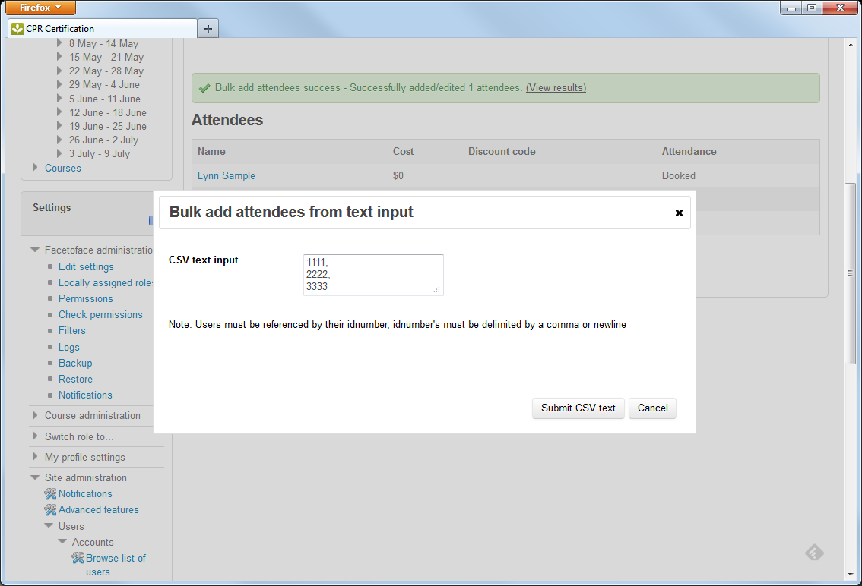
Attendees can be removed using the Add/remove attendees option.
When an attendee is booked for a session, they may receive a confirmation of that booking, if the option has been enabled.

Trainer Workflow

Bulk Message Users
After a session has been created, the trainer can send out custom messages to users as needed.
Click on the Face-to-face activity in the course page.
Go to the session that you wish to send a message for and click on the Message users tab.
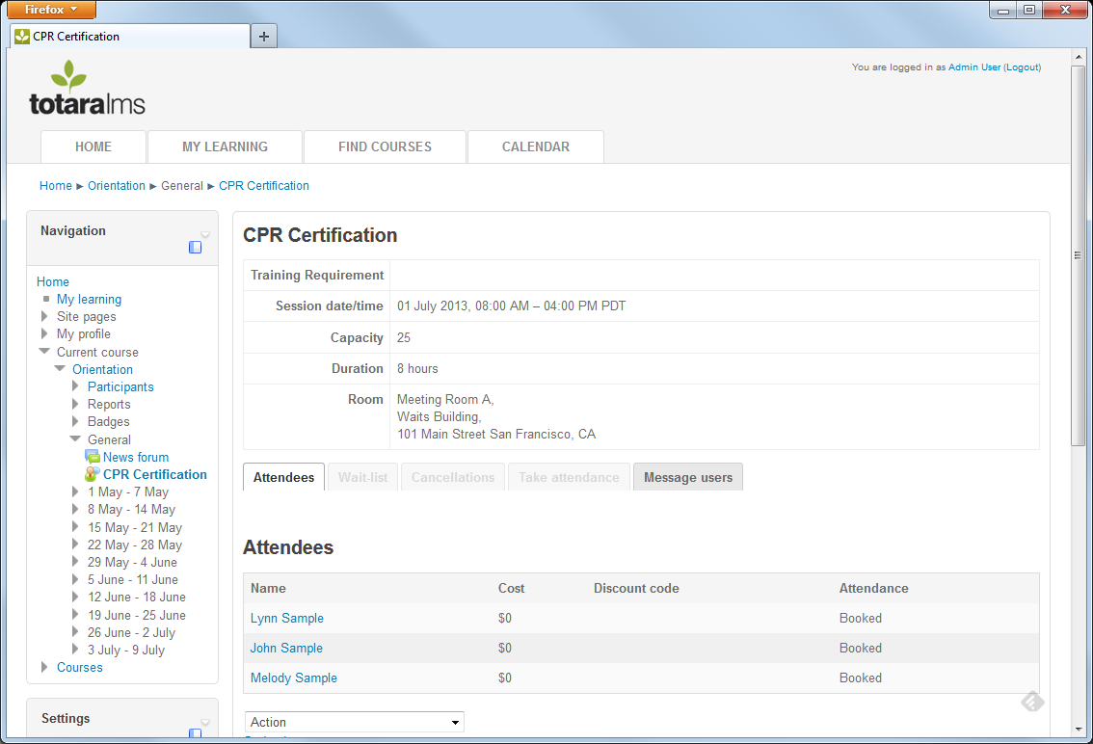
Place a tick in the check box next to any Recipient Groups that the message should go to. This could include users that are Booked, wait-listed or who cancelled their booking. If the message is sent after attendance has been taken, additional groups will be displayed based on the user’s attendance status (No Show, Partially attended, Fully attended).
Enter the message Subject and Body that will be sent.
Click the Send message button at the bottom of the screen.
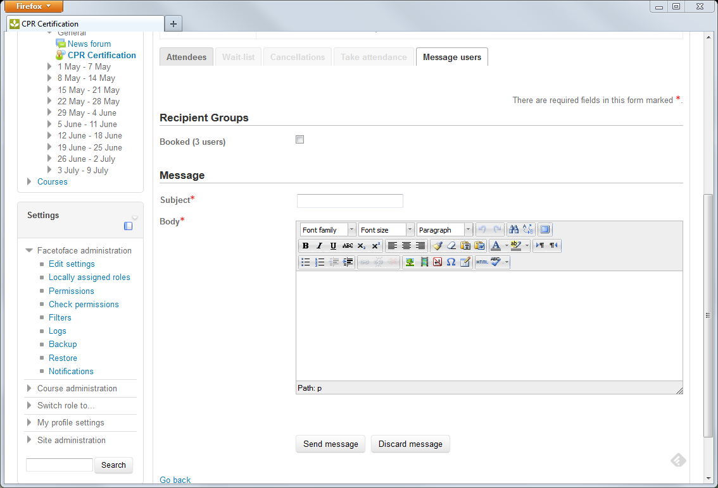

Take Attendance for a Session
Once attendees are booked for the session and the session date and time occurs in the past, the trainer has the ability to take attendance.
Click on the Face-to-face activity in the course page.
Go to the session that needs to be marked and click on the Attendees link. Notice that this may appear to be greyed out, if the session has already ended.
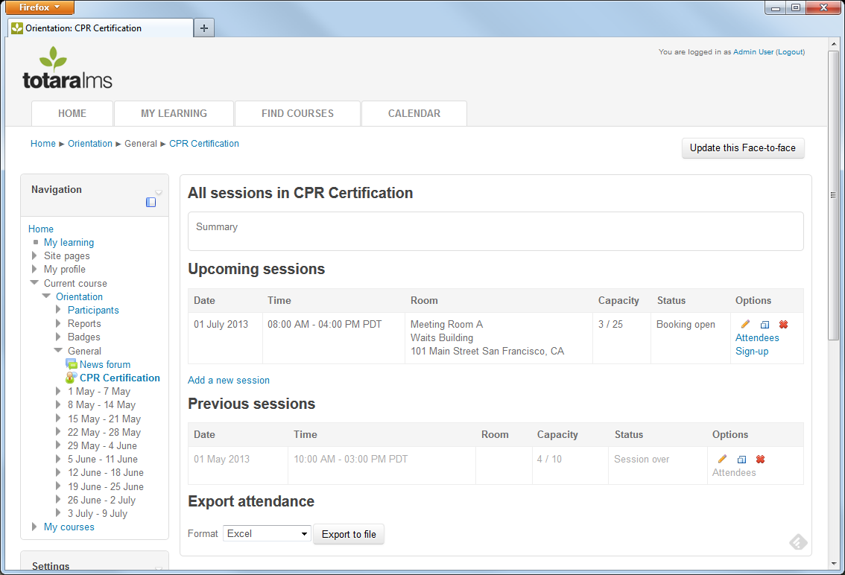
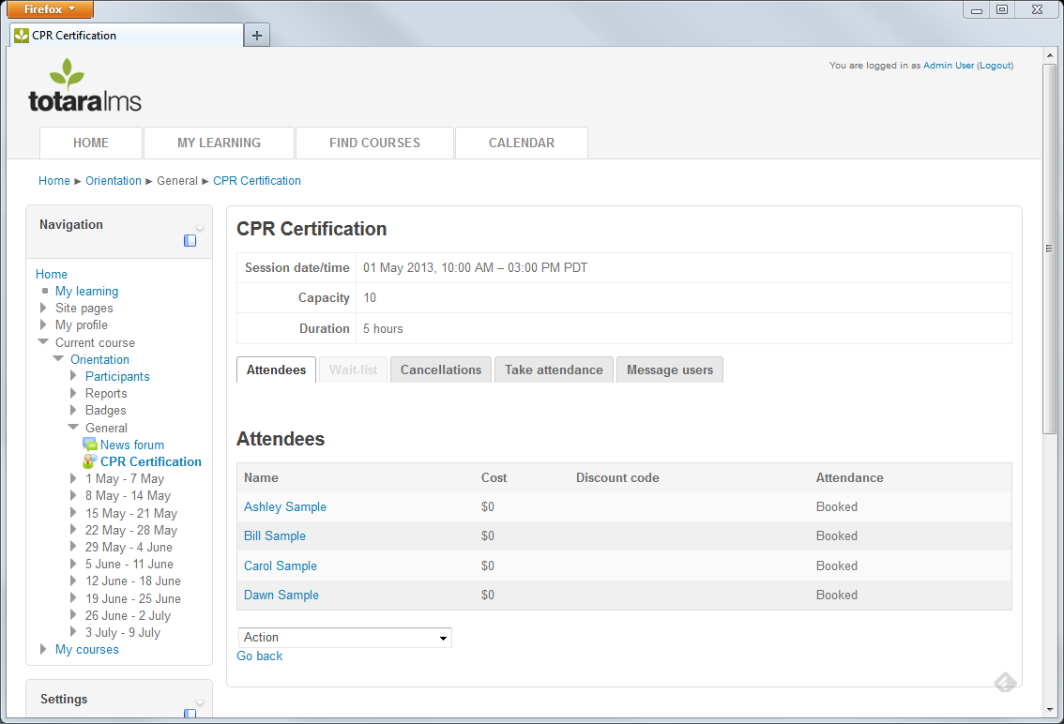
Click on the Take Attendance tab.

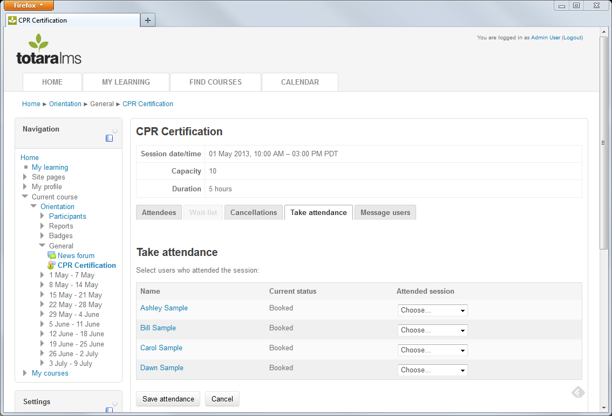
Next to each learner, click on the dropdown in the Attended session column. Select whether the learner was a No Show, Partially Attended, or Fully Attended the session.
Click the Save attendance button at the bottom of the screen to save these changes.

Learner Workflow

View Sessions
Learners can view Face-to-face sessions in four areas: Site-wide calendar, course calendar, course page and activity page.

Site wide Calendar
The Site wide Calendar is available using the Calendar tab in the Navigation bar. The URL for the calendar is https://mydomain/calendar/view.php
Learners can view any sessions for a Face-to-face activity that has been set to display in the site wide calendar. The learner can choose to view sessions from All Courses or select a specific course in the Upcoming events list. A Sign-up for this Face-to-face session link will appear at the bottom of any sessions that the learner can sign up for.
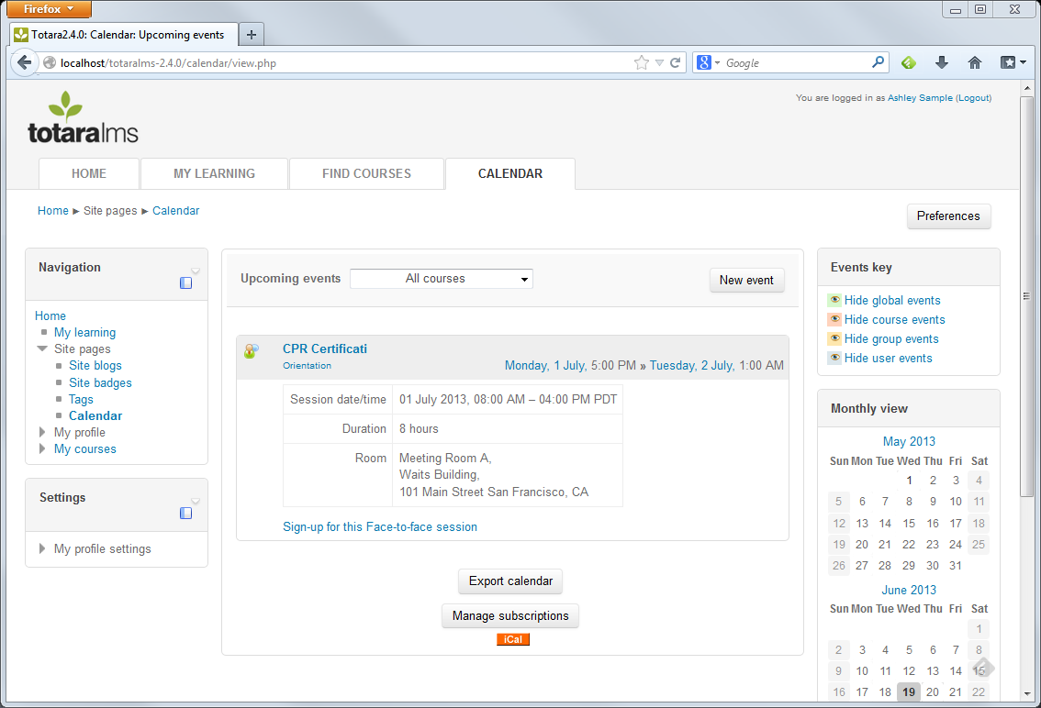
The learner can view only those events that they have signed up for by hiding the global, course and group events using the Events key option in the Calendar.

Course Calendar
The course calendar displays sessions for Face-to-face activities that have been setup in the current course only. The calendar appears as a block on the side of the page.
If the calendar block does not appear, Editing Trainers and Course Creators can add the block to the page. To add this block to a course page, click the Turn editing on button.
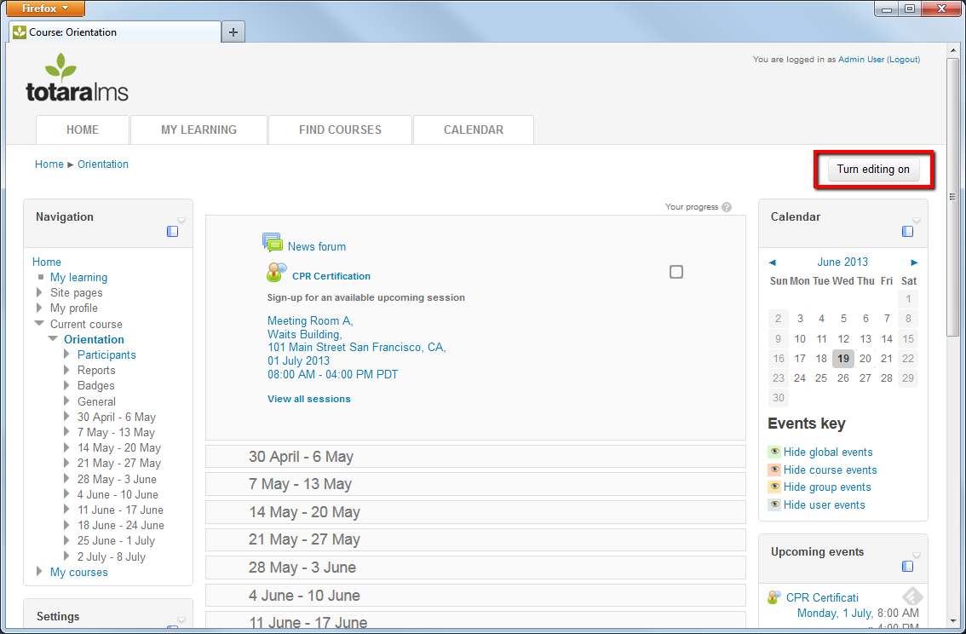
Scroll to the bottom of the page to the Add a block list and select Calendar. The calendar displays the current month and any calendar events will appear.
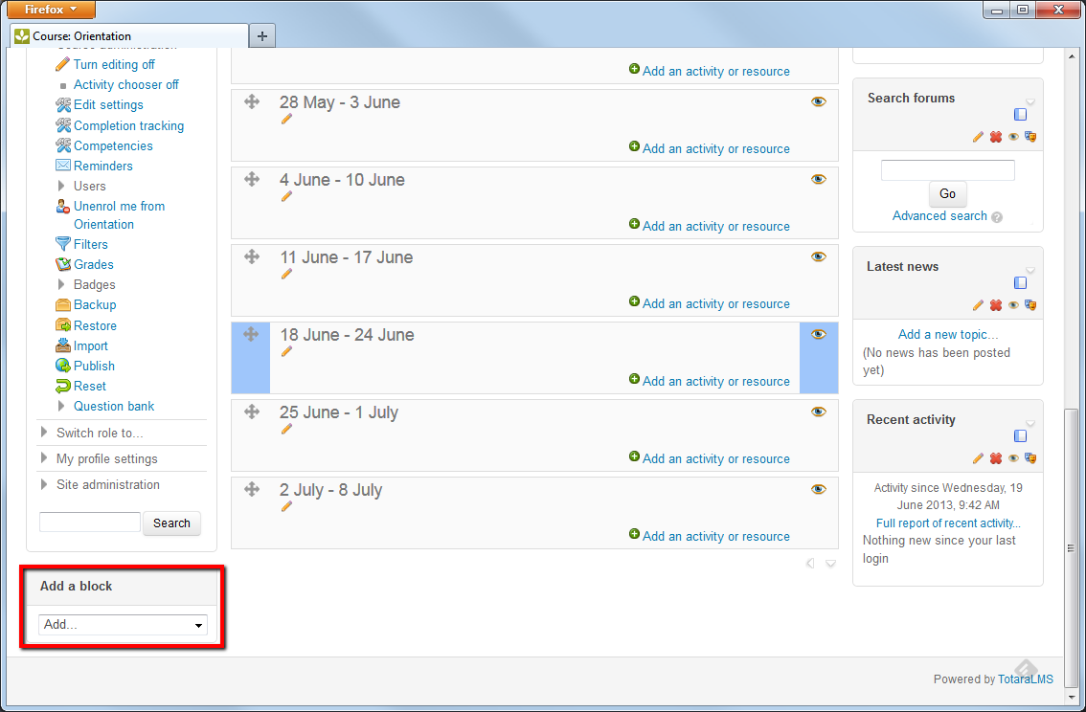
The Upcoming events block is also useful to add because it provides a text display of upcoming events along with the calendar’s graphical representation.
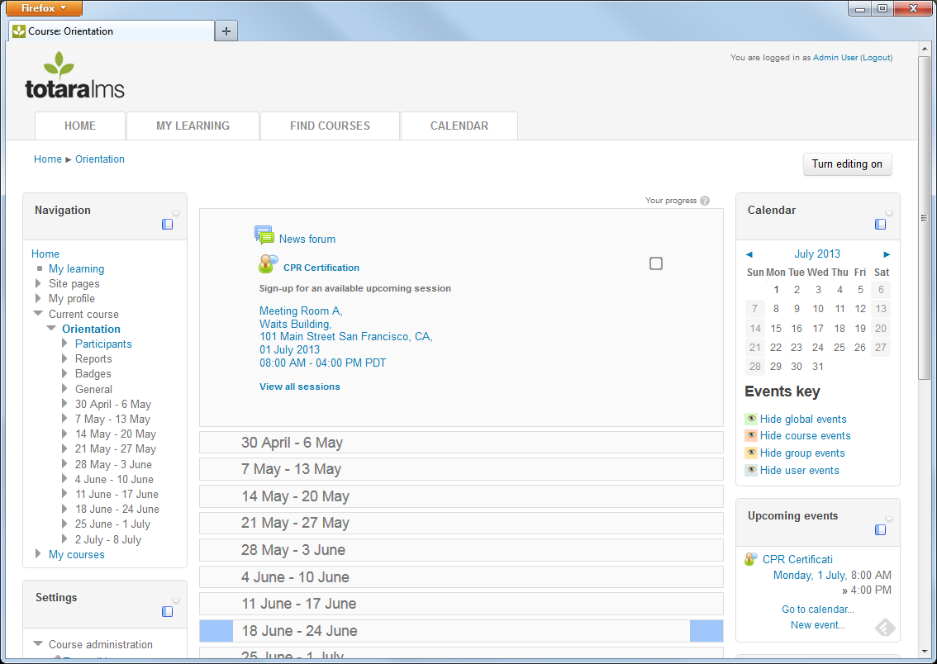
Hovering the mouse over a date will bring up a list of any events scheduled for that day.
To view more details of the event, click on the event title.
To view more events in the course calendar, click on the Month.
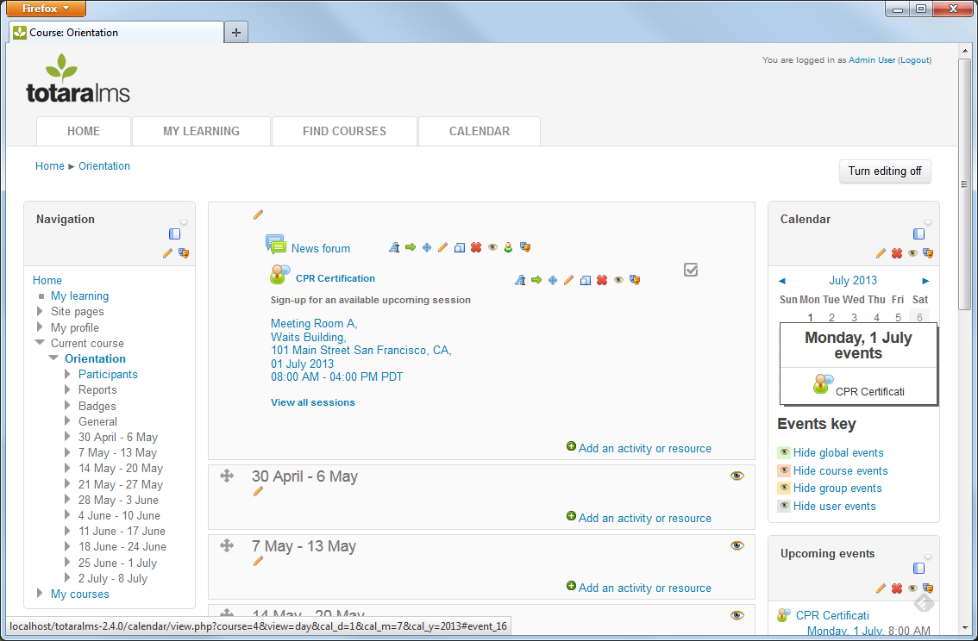

Course Page
Go to the course page and scroll down to the Face-to-face activity. A list of the soonest, upcoming, available sessions appears on the course page.
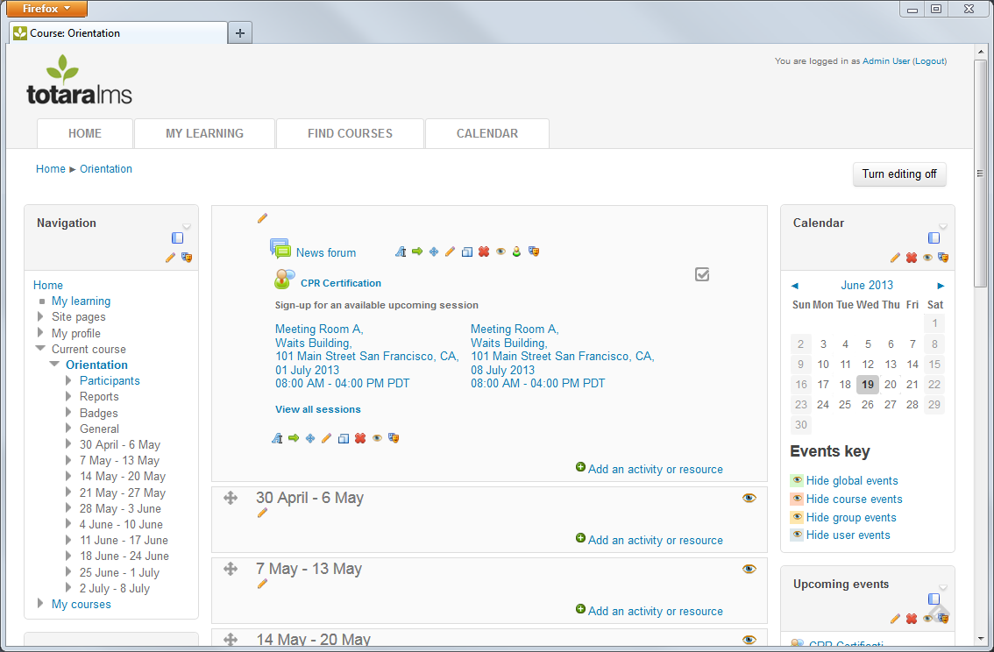
Click on a Session’s details or the View all sessions link to select the session to sign-up for.
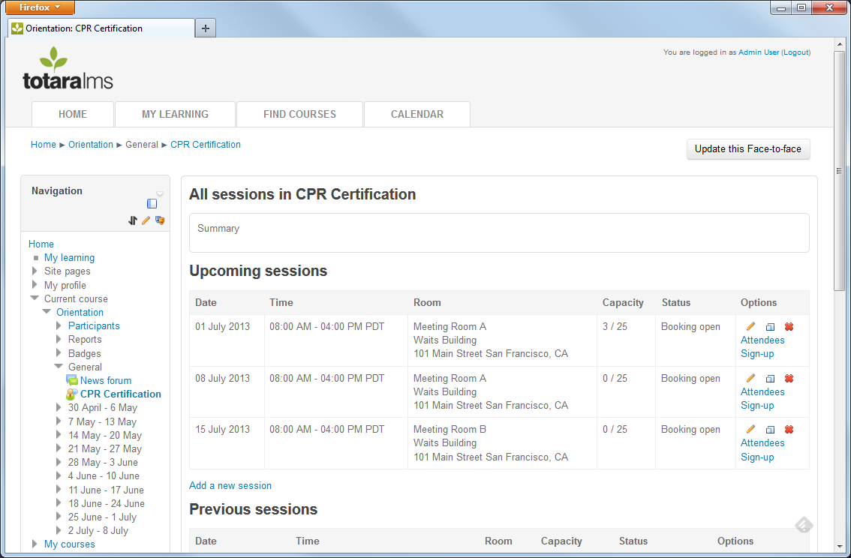

Sign-up for a Session
Additional action may be required from the Learner and their Manager to sign-up for and approve attendance of a session, respectively.
Learners can sign-up for a session, rather than requiring the Trainer to book them.
Click on the Sign-up link next to a session.
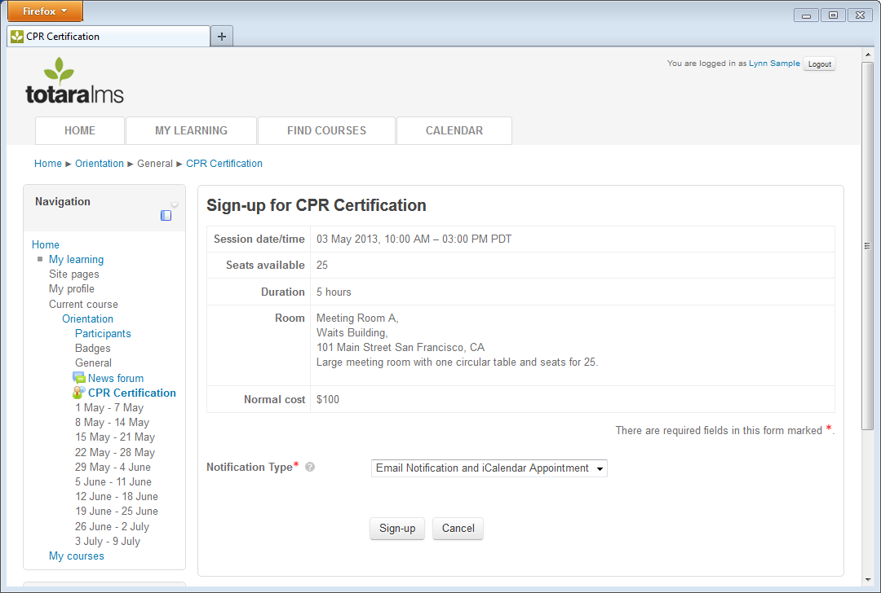
Choose the Notification type that you would like to receive after you sign up for this session: Email Notification and/or iCalendar Appointments are available and will contain the date, time, location and details of the session.
If a Discount Cost was entered in the Session settings page, the learner will be required to enter a Discount Code. Note that this discount code is not validated by the system; it is stored and available for review via the Face-to-face Session reports found in My Reports. When the code is entered, the discount cost will be associated with the learner for this session.
If the Manager’s email address is required in the Site Administration settings, then the user will be asked to enter their Manager’s email address.
Click the Sign-up button to book the session. You will receive a confirmation email and a notification will appear on the Alerts section of the My Learning dashboard.
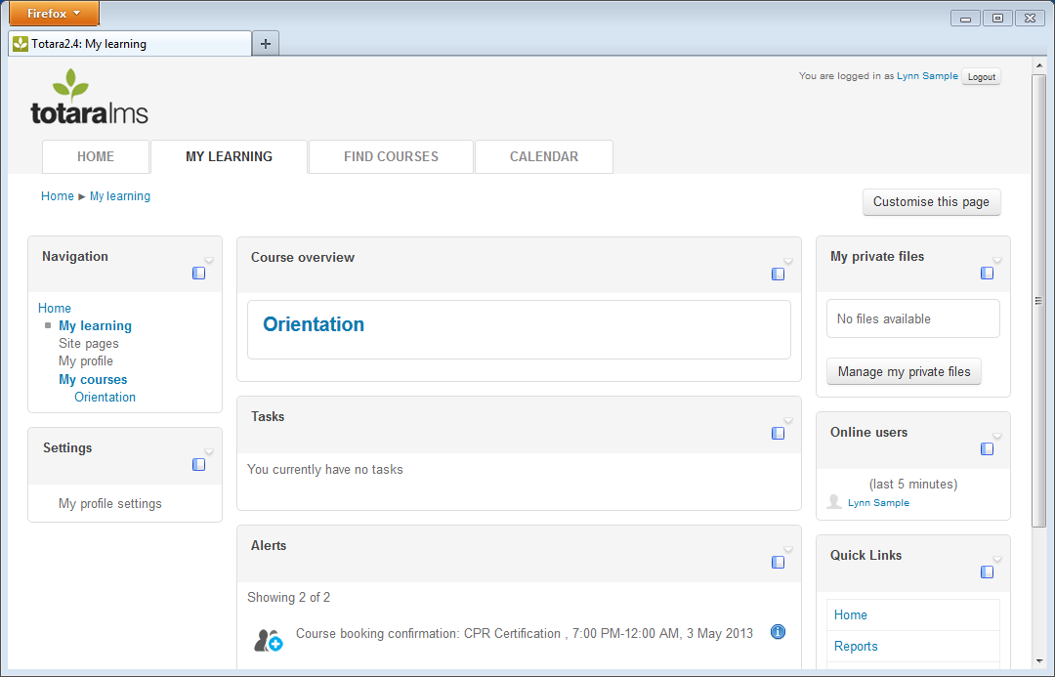
The session will also appear in the My Learning > My Bookings page and on the Calendar.

Sign-up for a Session without a Known Date and Time
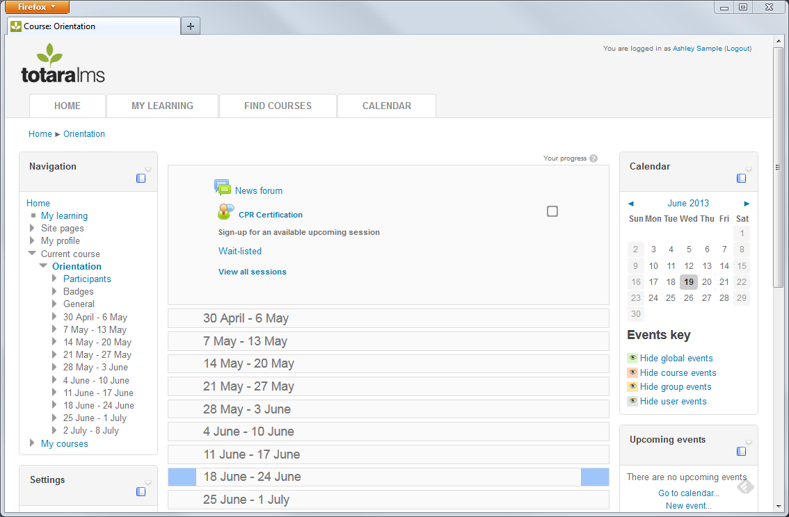
Wait-listed sessions are used by Session Creators to capture interest in a session that has not yet been scheduled. The learner can click on the Wait-listed link to sign up for the session.
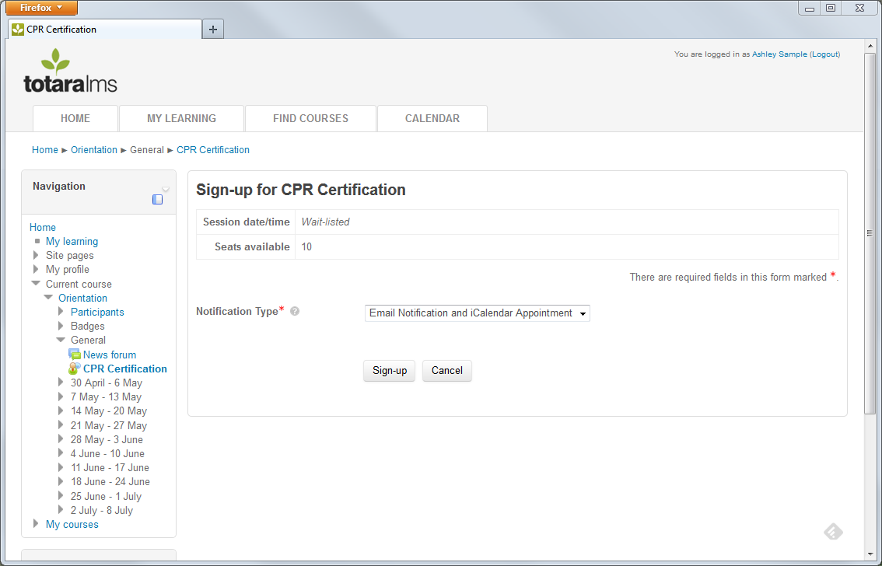
If enough learners sign-up for the session, the Session Creator can add a date and time and location to the session.
After the date is set, a booking confirmation will be sent to all users on the waitlist. Note that no iCal attachments will be sent until the session date is setup. If manager approval is required, the booking request will be sent to the manager.
The user will also receive alerts confirming their addition to the wait-list and confirming their booking on the My Learning dashboard.

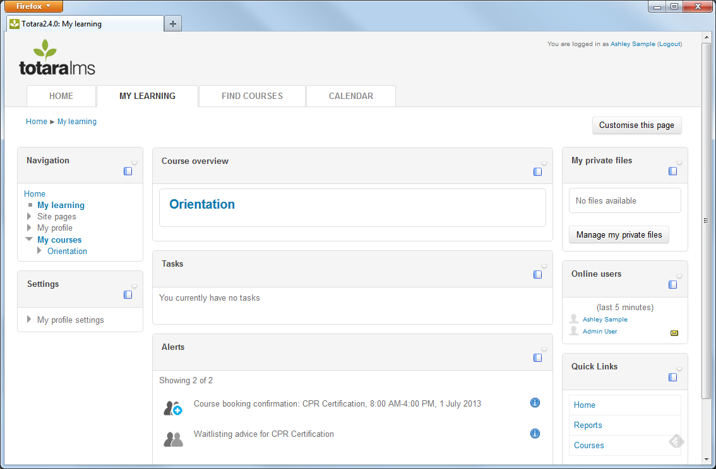

View Current and Past Session Bookings
Learners can return to the ‘My Bookings’ section of My Learning to see all current and past bookings.
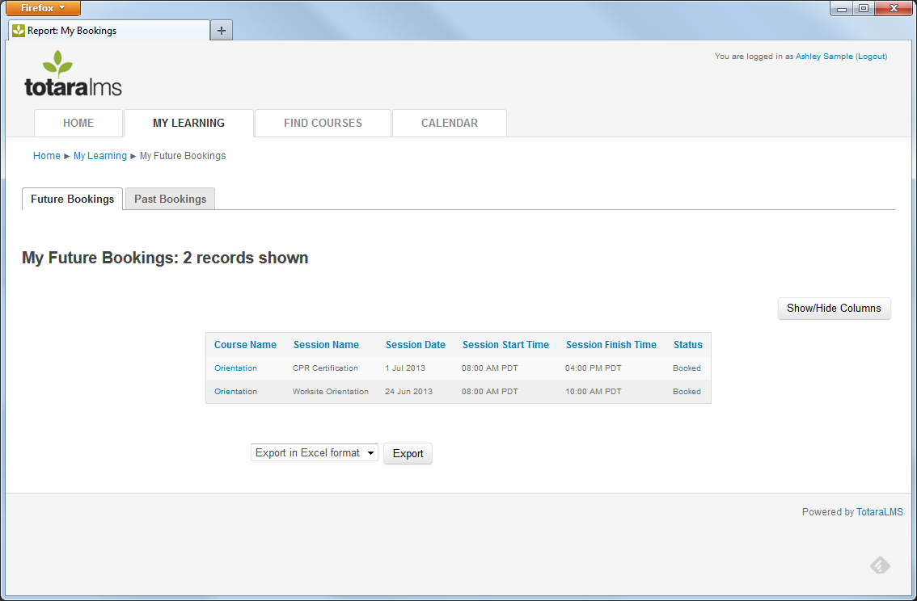

Sign-up for a Session Waitlist

Sessions without a Known Date and Time
A session is considered ‘Wait-listed’ if a time has not been set. The learner can sign-up for the session, but will not receive any iCal attachments until the date/time has been set.

Sessions Booked to Capacity and Allow Overbooking
A learner can also be added to a Wait-list for a session that allows overbooking. Every session has a maximum capacity or number of seats that are available for learners. When a session allows overbooking, learners can continue signing up for the session after it is full and will be added to the wait-list. If confirmed learners cancel their booking, then wait-listed learners will be confirmed for the booking.

Cancel from a Session
If a learner needs to cancel their booking for an event, they can access the session and click the Cancel booking link. Learners can cancel bookings for sessions that they have signed up for or sessions that an instructor has signed them up for.
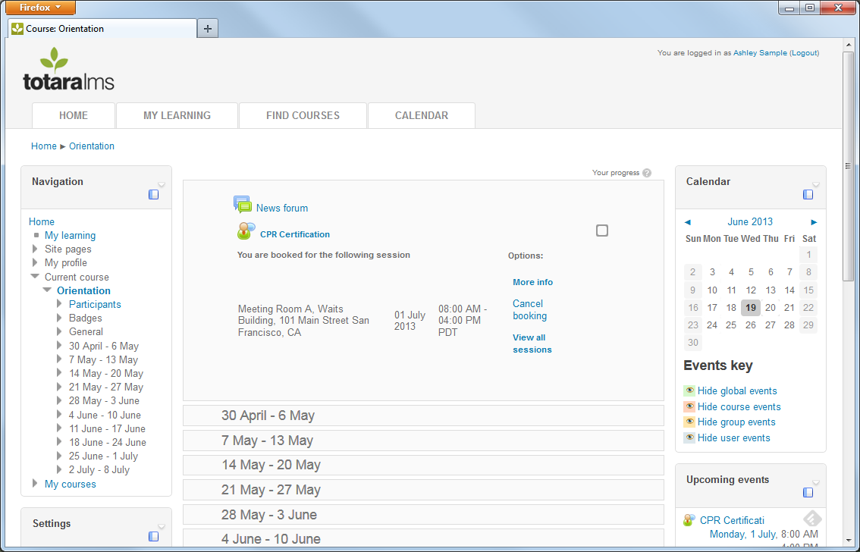
When cancelling, the learner will be asked to provide a reason for the cancellation.
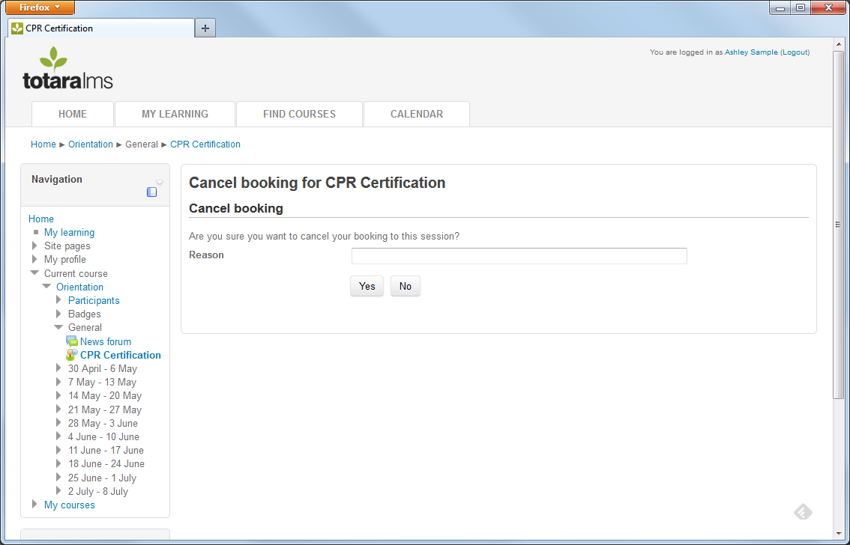
The learner will receive a confirmation notification for cancelling the session on the My Learning screen under Alerts. 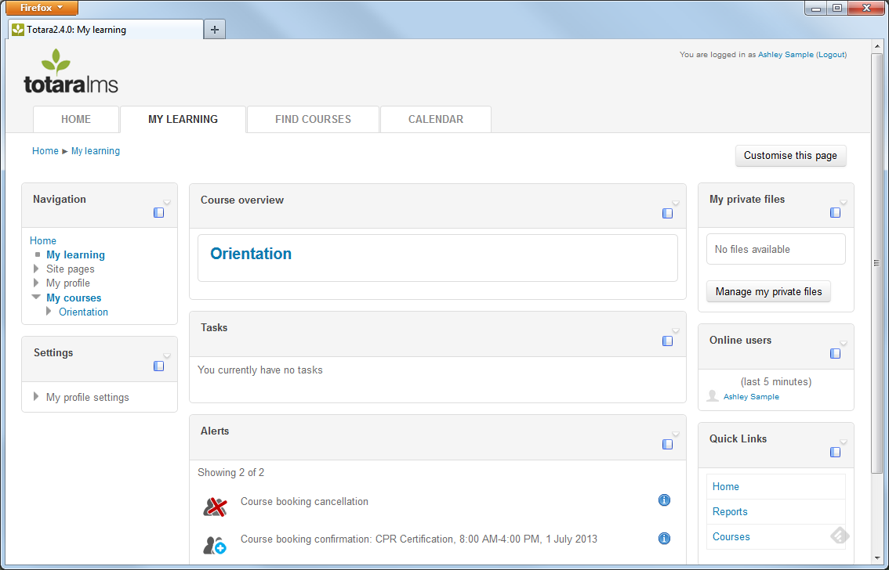
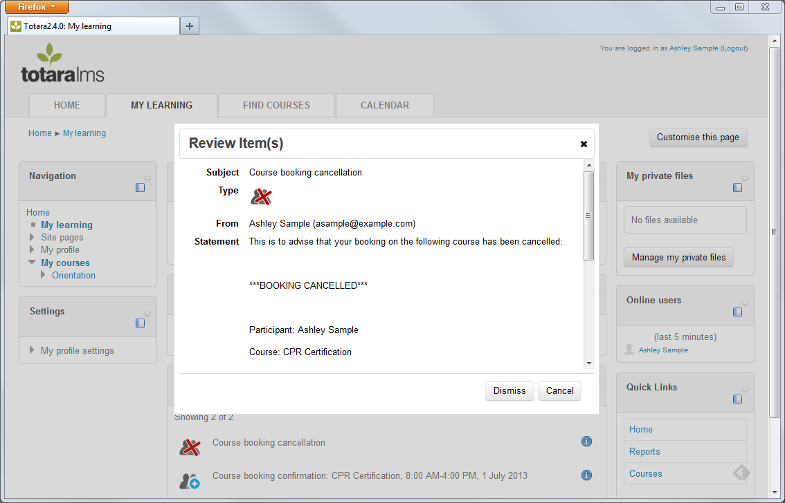
Notifications will also be sent to the learner via email.
If an instructor cancels a session or changes the session’s date(s) / time(s), a notification will be sent to the user with an updated iCal event attached.

Manager Workflows

Session request approval
Some sessions will require manager approval for a learner to sign-up or be booked. This is based on a setting called Approval required in the Face-to-face activity settings page.
After the learner uses the sign-up option, a Course Booking Request for manager approval will appear as a notification in the Tasks section of the manager’s My Learning dashboard.
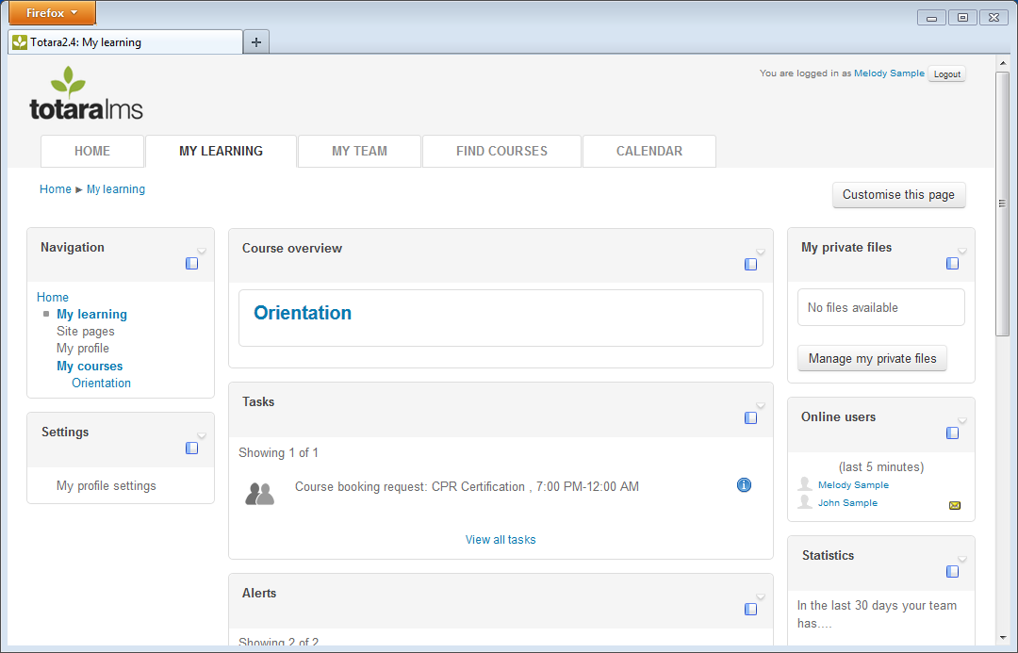
The manager may also receive an email notifying them that the learner has requested to attend a session. Clicking on the information icon next to the task will bring up the same message that appears in the email, including a link for the manager to click on.

Viewing team bookings
Managers can view bookings for each learner on their team via the My Team page. Under the name of each team member, a link labeled ‘Bookings’ appears. By clicking on the link, a Manager can see a report of all sessions that the learner has been booked into, as well as information about the session including Course name, Session name, Session Date, Session Start Time, Session Finish Time, and the Learner’s Status (e.g., Booked, Attended, etc). The Manager can also export the table to a spreadsheet.

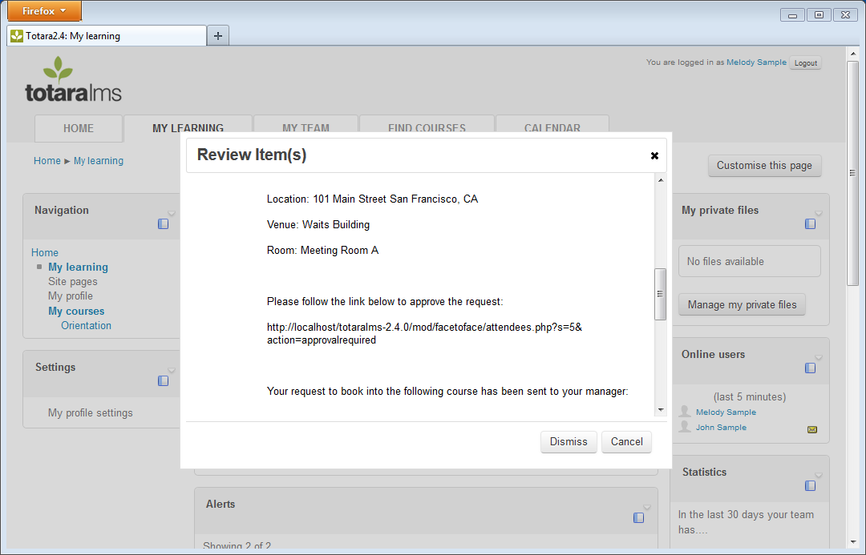
The link takes the manager to the session approval page.
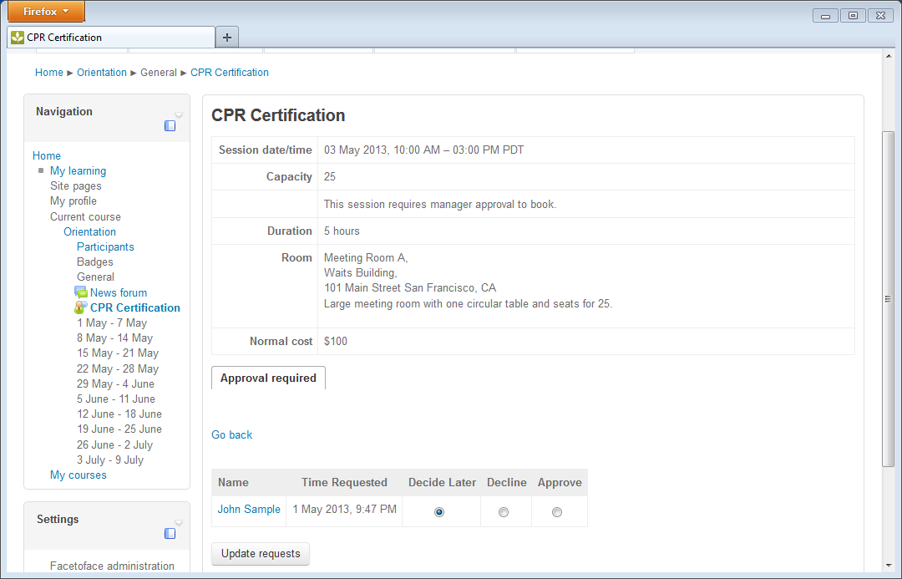
For each learner that requires approval, select the Decline or Approve radio button. Click the Update requests button to save the changes.
The learner is now fully booked for the session.

Frequently Asked Questions
- What happens when a learner signs up for a session that does not have a date/time set?
Sessions that do not include a date/time are considered as a Wait-listed session. Learners will be added to the wait-list and will receive a notification message that they have been added to the wait-list. Once the date/time is set, Manager’s will receive approval requests, if necessary. The learner will be confirmed for the session and receive a booking confirmation notification.

- Why doesn’t the learner’s session appear on the My Bookings list?
A session without a date and time will not appear in the My Bookings list because the date and time is not set.
- Learners are not receiving iCal attachments for all of the session dates for multi-day sessions.
If your organization is using Microsoft Outlook, learners will need to receive a separate iCal invitation for each day of a multi-day session. Enable the One message per day option by going to the Settings block under Site Administration > Plugins > Activity Modules > Face-to-face.

