Screenshot 1 – all certifications (accessed by clicking the number in “previous completions” in the record of learning/certification

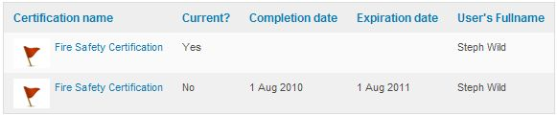

Screenshot 2 – record of attendance on the course that is contained in the certification

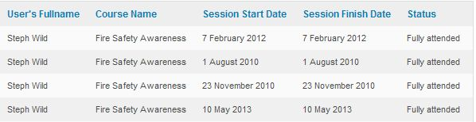

Screenshot 3 – record of learning/certification

