Grader Report – Showing 3 Offline Activities aligned to the Assess Group. When an attempt is marked as Competent, category and course totals update to 100.00. When an attempt is marked as Not Yet Competent, the category and course totals remains as 0, which is correct.
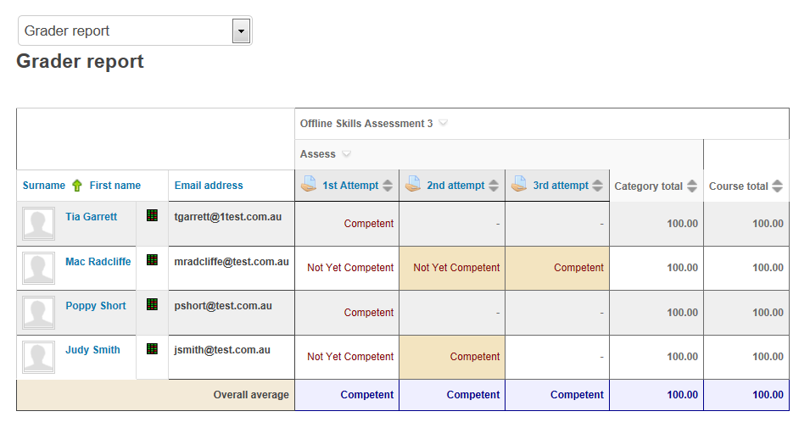
The overall course completion (as seen in the Course Completion Report example below) doesn’t update.
