Course Completions for Test Course 1 (where CLAD Test 2 is the correct name for Test Course 2!).

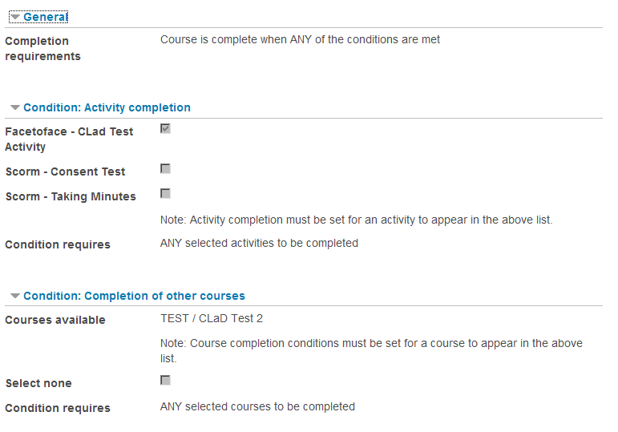

Course Completions report from 22/9/2014, Test Course 1 has not completed.

