This is from the Lumitt training website (scroll down to 2nd screen capture to see what I have in my live system):
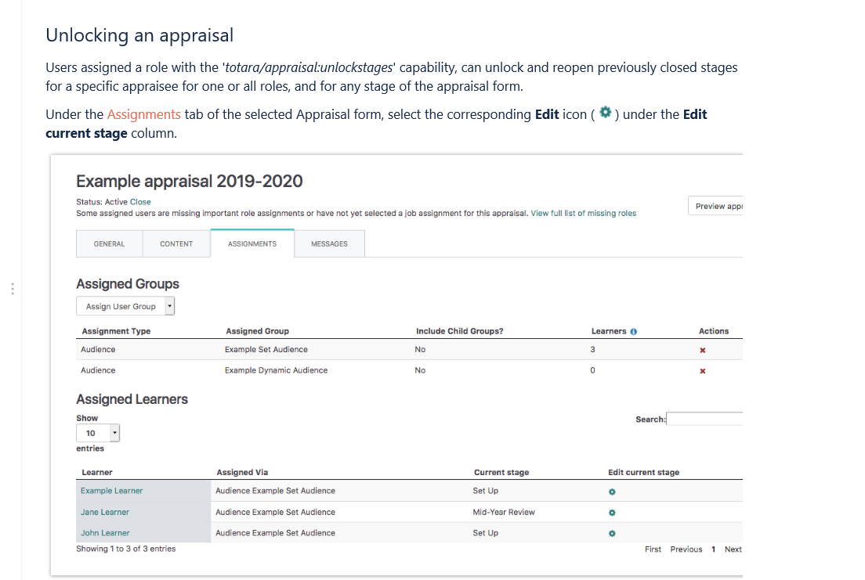

What I Actually See
