The course was previously taken and failed on the 7th April, then retaken on the 11th Aug – the questions needed to pass the activity are in the Case Studies section

SS1 - Failed quiz and only taken some of the sections – screenshot when returning to the module.
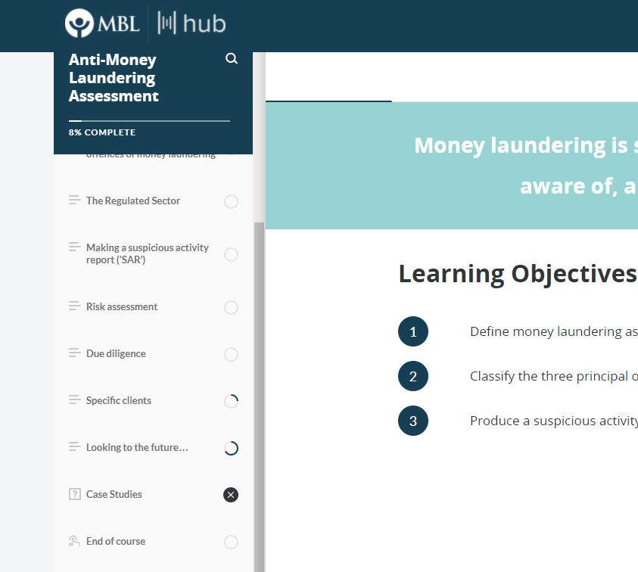

SS2 - Passed the quiz second time (100%)

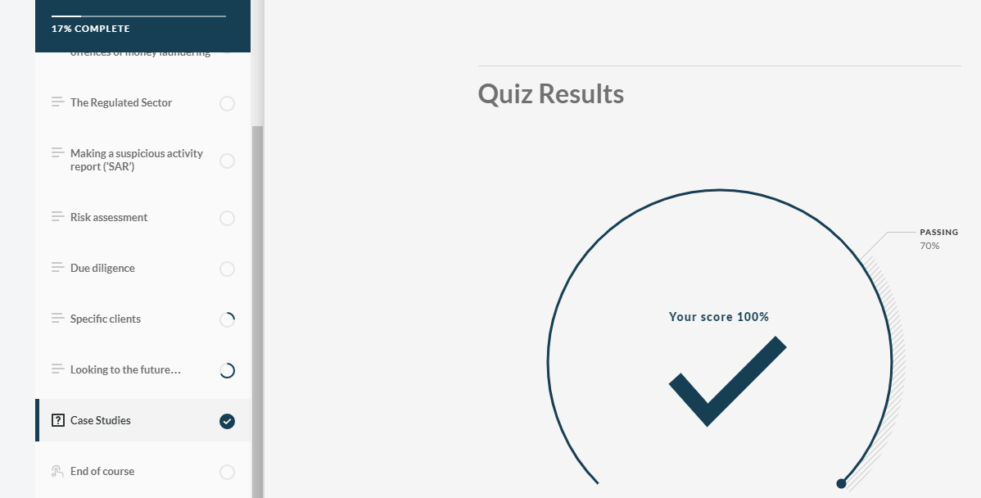

Module doesn’t mark as a completed course in Totara and when I re-enter it now shows X against the quiz
SS3 - Re-enter the Case Studies Quiz and it shows the score from the first attempt

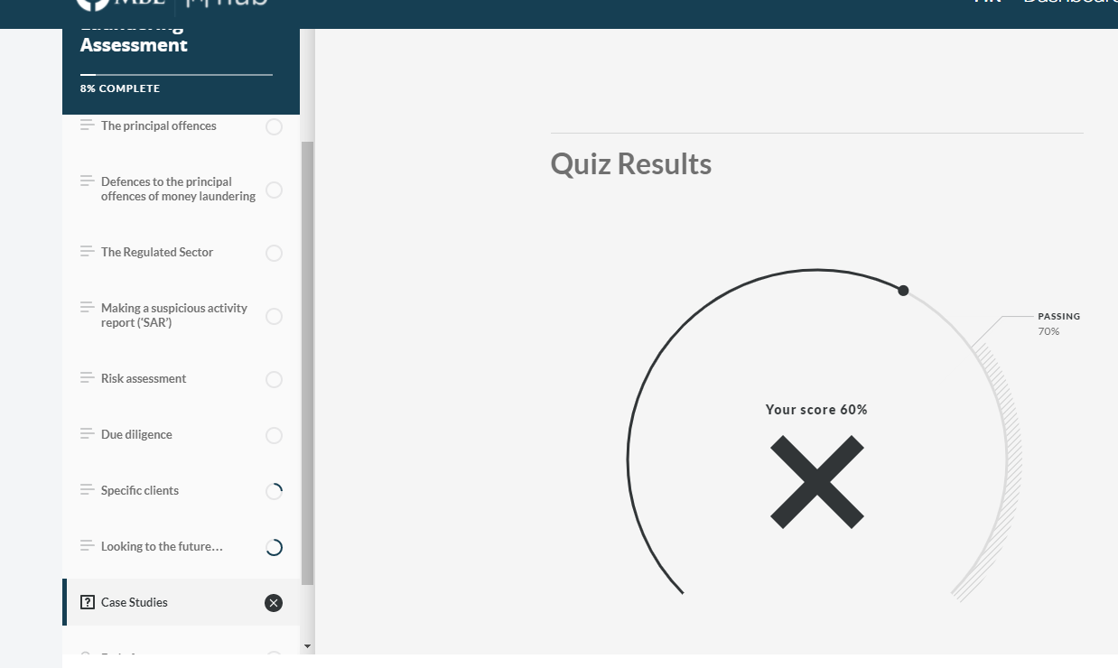

Looking in the logs there is a record of the user going into the course on the 11th Aug (when the quiz was retaken)
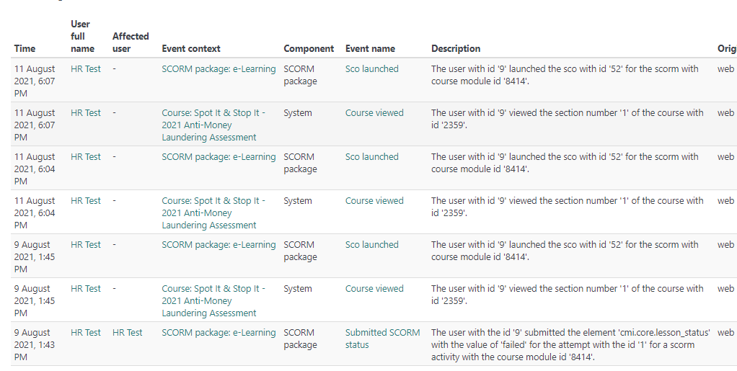
But when looking at the scorm INTERACTIONS REPORT it does not show this on the “last accessed on” and the score is not correct, since the user had passed it with 100%
