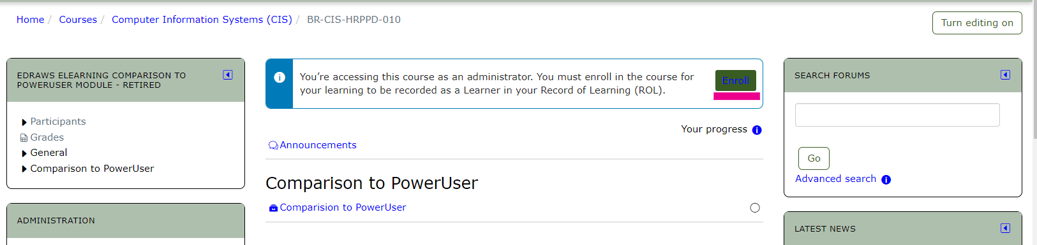

Receive an administrator enrollment message as shown above for various types of courses such as blended (topics), but do not receive an administrator message for a seminar nor an e_learning course as shown below.

Seminar:

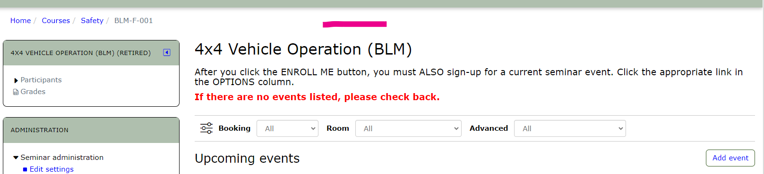

e-Learning  
