Example of how the Save Changes could be placed

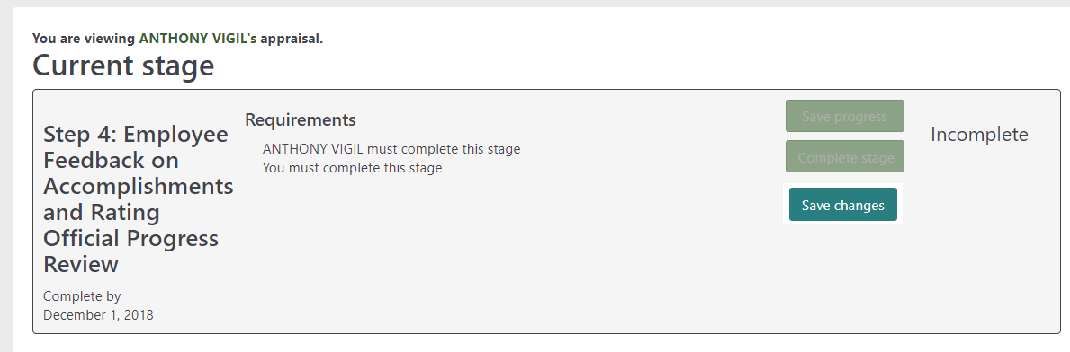

Previous to the Totara 11 release

