**View when completing quiz (multi-line responses sit below radio button)**

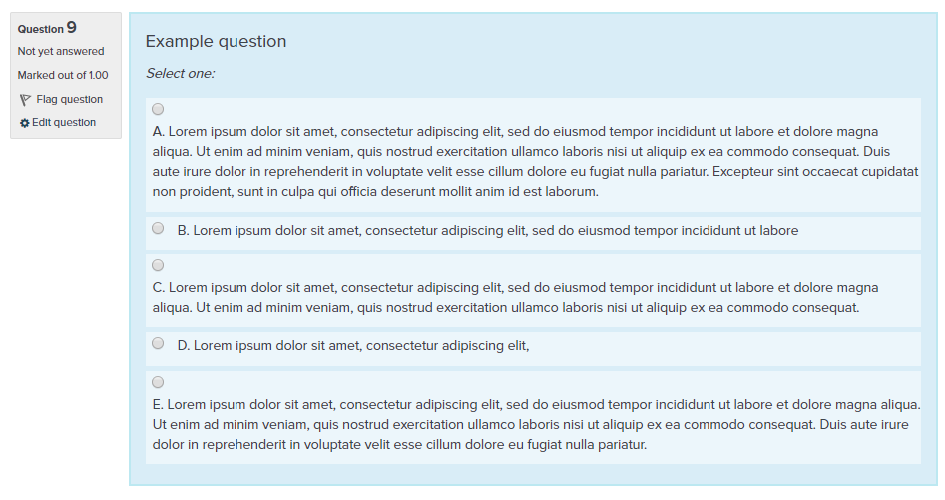

**View when previewing a question within the question – (all text aligned beside radio button)**

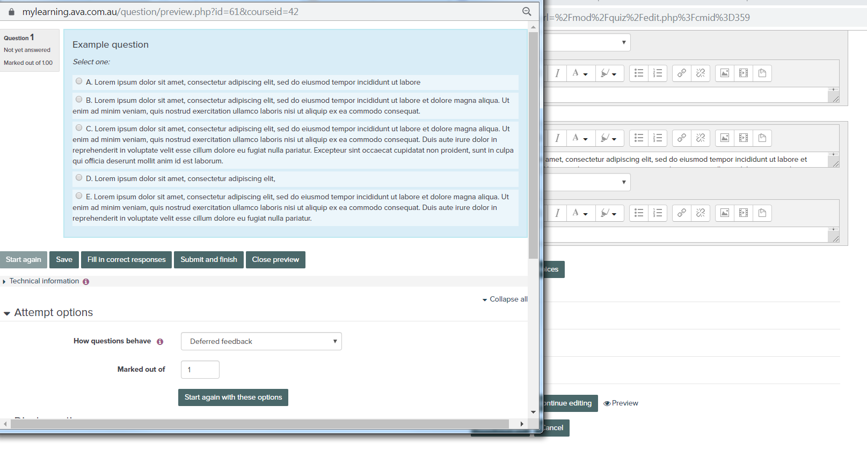

**View when reviewing quiz attempt – (all text aligned beside radio button)**

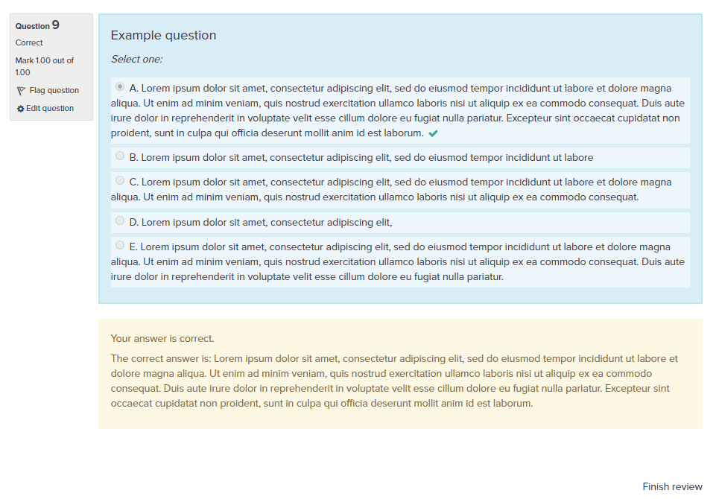

**Quiz answer 1, html view (tried all the below):**

**View 1:**

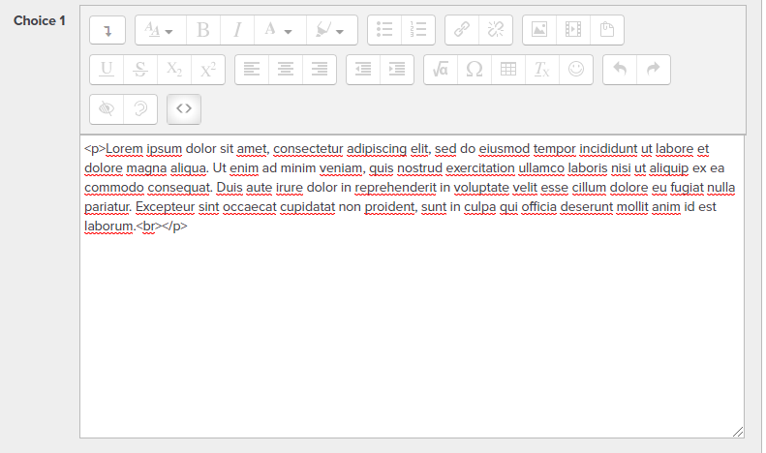

**View 2:**

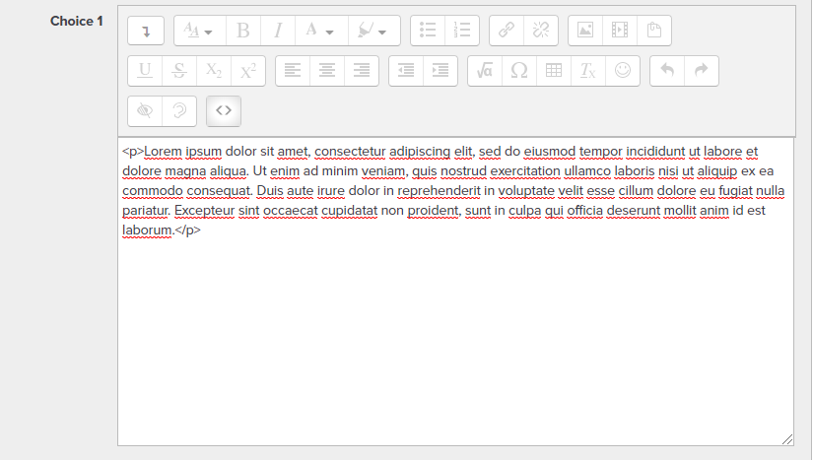

**View 3**

