Example of how Company, then Division, then Branch, then Role are set up – our view from adding a job assignment to user, all of ours are kept under organization. There is nothing available under ‘position’.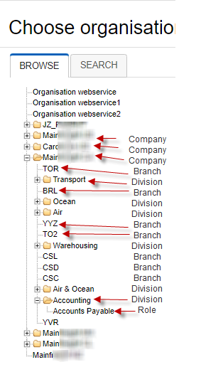
Examples of user’s Organizational set-up with company, division, branch, role
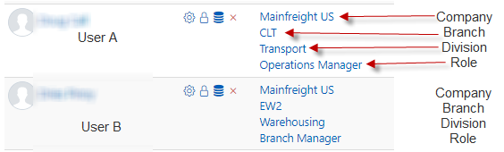

The only way I can get into Excel, using Job Title column. This does not allow our ‘higher level’ team members to easily filter to see one division at a time, one branch at a time, etc.
